element ChangeofTrackMessage

diagram | 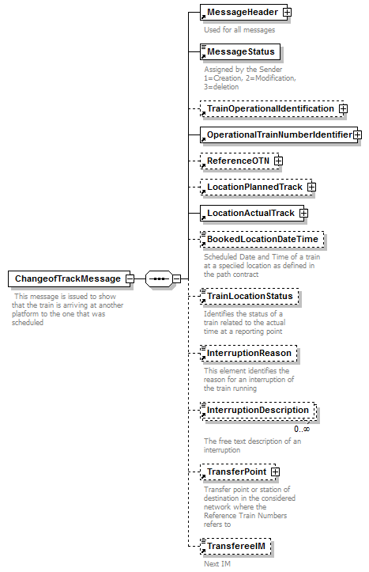
properties | content complex
children | MessageHeader MessageStatus TrainOperationalIdentification OperationalTrainNumberIdentifier ReferenceOTN LocationPlannedTrack LocationActualTrack BookedLocationDateTime TrainLocationStatus InterruptionReason InterruptionDescription TransferPoint TransfereeIM
annotation | documentation  This message is issued to show that the train is arriving at another platform to the one that was scheduled
source | <xs:element name="ChangeofTrackMessage">  <xs:annotation>  <xs:documentation> This message is issued to show that the train is arriving at another platform to the one that was scheduled</xs:documentation>  </xs:annotation>  <xs:complexType>  <xs:sequence>  <xs:element ref="MessageHeader"/>  <xs:element ref="MessageStatus">  <xs:annotation>  <xs:documentation>Assigned by the Sender 1=Creation, 2=Modification, 3=deletion </xs:documentation>  </xs:annotation>  </xs:element>  <xs:element ref="TrainOperationalIdentification" minOccurs="0"/>  <xs:element ref="OperationalTrainNumberIdentifier"/>  <xs:element ref="ReferenceOTN" minOccurs="0"/>  <xs:element ref="LocationPlannedTrack" minOccurs="0"/>  <xs:element ref="LocationActualTrack"/>  <xs:element ref="BookedLocationDateTime" minOccurs="0">  <xs:annotation>  <xs:documentation>Scheduled Date and Time of a train at a speciied location as defined in the path contract</xs:documentation>  </xs:annotation>  </xs:element>  <xs:element ref="TrainLocationStatus" minOccurs="0"/>  <xs:element ref="InterruptionReason" minOccurs="0"/>  <xs:element ref="InterruptionDescription" minOccurs="0" maxOccurs="unbounded"/>  <xs:element ref="TransferPoint" minOccurs="0">  <xs:annotation>  <xs:documentation>Transfer point or station of destination in the considered network where the Reference Train Numbers refers to </xs:documentation>  </xs:annotation>  </xs:element>  <xs:element ref="TransfereeIM" minOccurs="0"/>  </xs:sequence>  </xs:complexType>  </xs:element>

element LocationActualTrack
diagram | 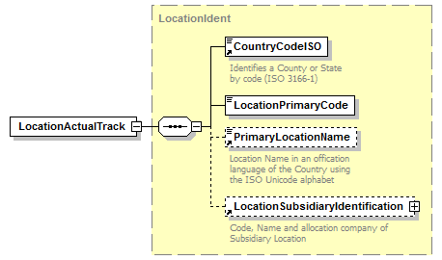
type | LocationIdent
properties | content complex
children | CountryCodeISO LocationPrimaryCode PrimaryLocationName LocationSubsidiaryIdentification
used by | element ChangeofTrackMessage
source | <xs:element name="LocationActualTrack" type="LocationIdent"/>

element LocationPlannedTrack
diagram | 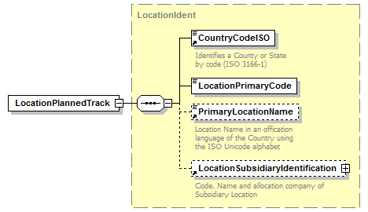
type | LocationIdent
properties | content complex
children | CountryCodeISO LocationPrimaryCode PrimaryLocationName LocationSubsidiaryIdentification
used by | element ChangeofTrackMessage
source | <xs:element name="LocationPlannedTrack" type="LocationIdent"/>

