element TrainJourneyModificationMessage
diagram | 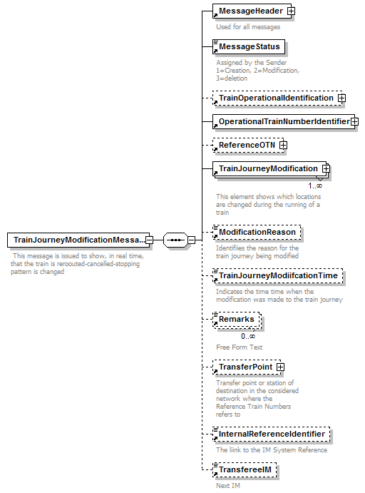
properties | content complex
children | MessageHeader MessageStatus TrainOperationalIdentification OperationalTrainNumberIdentifier ReferenceOTN TrainJourneyModification ModificationReason TrainJourneyModiifcationTime Remarks TransferPoint InternalReferenceIdentifier TransfereeIM
annotation | documentation  This message is issued to show, in real time, that the train is reroouted-cancelled-stopping pattern is changed
source | <xs:element name="TrainJourneyModificationMessage">  <xs:annotation>  <xs:documentation> This message is issued to show, in real time, that the train is reroouted-cancelled-stopping pattern is changed</xs:documentation>  </xs:annotation>  <xs:complexType>  <xs:sequence>  <xs:element ref="MessageHeader"/>  <xs:element ref="MessageStatus">  <xs:annotation>  <xs:documentation>Assigned by the Sender 1=Creation, 2=Modification, 3=deletion </xs:documentation>  </xs:annotation>  </xs:element>  <xs:element ref="TrainOperationalIdentification" minOccurs="0"/>  <xs:element ref="OperationalTrainNumberIdentifier"/>  <xs:element ref="ReferenceOTN" minOccurs="0"/>  <xs:element ref="TrainJourneyModification" maxOccurs="unbounded"/>  <xs:element ref="ModificationReason" minOccurs="0"/>  <xs:element ref="TrainJourneyModiifcationTime" minOccurs="0"/>  <xs:element ref="Remarks" minOccurs="0" maxOccurs="unbounded"/>  <xs:element ref="TransferPoint" minOccurs="0">  <xs:annotation>  <xs:documentation>Transfer point or station of destination in the considered network where the Reference Train Numbers refers to </xs:documentation>  </xs:annotation>  </xs:element>  <xs:element ref="InternalReferenceIdentifier" minOccurs="0"/>  <xs:element ref="TransfereeIM" minOccurs="0"/>  </xs:sequence>  </xs:complexType>  </xs:element>

element TrainJourneyModification
diagram | 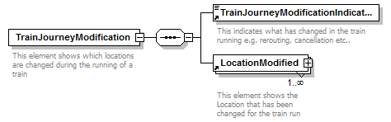
properties | content complex
children | TrainJourneyModificationIndicator LocationModified
used by | element TrainJourneyModificationMessage
annotation | documentation  This element shows which locations are changed during the running of a train
source | <xs:element name="TrainJourneyModification">  <xs:annotation>  <xs:documentation>This element shows which locations are changed during the running of a train</xs:documentation>  </xs:annotation>  <xs:complexType>  <xs:sequence>  <xs:element ref="TrainJourneyModificationIndicator"/>  <xs:element ref="LocationModified" maxOccurs="unbounded"/>  </xs:sequence>  </xs:complexType>  </xs:element>

element TrainJourneyModificationIndicator
diagram | 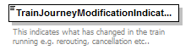
type | restriction of xs:integer
properties | content simple
used by | element TrainJourneyModification
facets | minInclusive 1  maxInclusive 99
annotation | documentation  This indicates what has changed in the train running e.g. rerouting, cancellation etc..
source | <xs:element name="TrainJourneyModificationIndicator">  <xs:annotation>  <xs:documentation>This indicates what has changed in the train running e.g. rerouting, cancellation etc..</xs:documentation>  </xs:annotation>  <xs:simpleType>  <xs:restriction base="xs:integer">  <xs:minInclusive value="1"/>  <xs:maxInclusive value="99"/>  </xs:restriction>  </xs:simpleType>  </xs:element>

element TrainJourneyModiifcationTime
diagram | 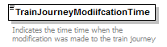
type | xs:dateTime
properties | content simple
used by | element TrainJourneyModificationMessage
annotation | documentation  Indicates the time time when the modification was made to the train journey
source | <xs:element name="TrainJourneyModiifcationTime" type="xs:dateTime">  <xs:annotation>  <xs:documentation>Indicates the time time when the modification was made to the train journey</xs:documentation>  </xs:annotation>  </xs:element>

element LocationModified
diagram | 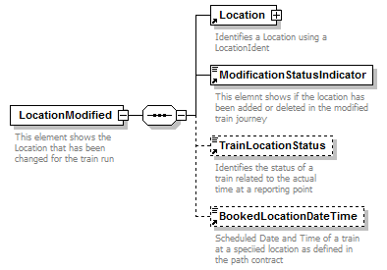
properties | content complex
children | Location ModificationStatusIndicator TrainLocationStatus BookedLocationDateTime
used by | element TrainJourneyModification
annotation | documentation  This element shows the Location that has been changed for the train run
source | <xs:element name="LocationModified">  <xs:annotation>  <xs:documentation>This element shows the Location that has been changed for the train run </xs:documentation>  </xs:annotation>  <xs:complexType>  <xs:sequence>  <xs:element ref="Location"/>  <xs:element ref="ModificationStatusIndicator"/>  <xs:element ref="TrainLocationStatus" minOccurs="0"/>  <xs:element ref="BookedLocationDateTime" minOccurs="0"/>  </xs:sequence>  </xs:complexType>  </xs:element>

element ModificationReason
diagram | 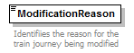
type | DelayCode
properties | content simple
used by | element TrainJourneyModificationMessage
facets | minInclusive 0000  maxInclusive 9999
annotation | documentation  Identifiies the reason for the train journey being modified
source | <xs:element name="ModificationReason" type="DelayCode">  <xs:annotation>  <xs:documentation>Identifiies the reason for the train journey being modified</xs:documentation>  </xs:annotation>  </xs:element>

element ModificationStatusIndicator
diagram | 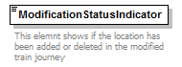
type | restriction of xs:integer
properties | content simple
used by | element LocationModified
facets | minInclusive 1  maxInclusive 99
annotation | documentation  This elemnt shows if the location has been added or deleted in the modified train journey
source | <xs:element name="ModificationStatusIndicator">  <xs:annotation>  <xs:documentation>This elemnt shows if the location has been added or deleted in the modified train journey</xs:documentation>  </xs:annotation>  <xs:simpleType>  <xs:restriction base="xs:integer">  <xs:minInclusive value="1"/>  <xs:maxInclusive value="99"/>  </xs:restriction>  </xs:simpleType>  </xs:element>

