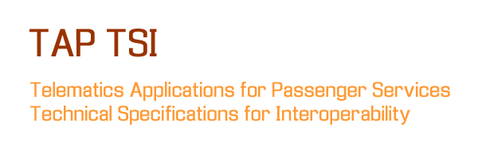

**PRM ASSISTANCE IT SPECIFICATIONS**

|  |  |
| --- | --- |
| **Project:** | **TAP Phase One** |
| Release: | 1.0 – To DG MOVE, ERA, TAP Steering Committee |
| Date: | 13 May 2012 |
| Author: | Ugo Dell’Arciprete (Work Stream Leader) |
| Owner: | TAP Phase One Project Team |
| Client: | DG MOVE, ERA |
| Document Ref: | PRM Assistance IT Specifications |
| Version No: | 1.0 |

# 1 Progress History

## 1.1 Document Location

This document will be uploaded to the “TAP TSI/TAP Retail activities/PRM assistance” folder of the project extranet.

## 1.2 Revision History

**Date of delivery: 13 May 2012**

|  |  |  |  |
| --- | --- | --- | --- |
| **Revision date** | **Previous revision date** | **Summary of Changes** | **Changes marked** |
| 2012-02-07 |  | First issue | None |
| 2012-05-10 | 2012-02-07 | Ch. 1.5, 7, 9, 10, glossary - general review |  |
| 2012-05-13 | 2012-05-10 | Final editing |  |

## 1.3 Approvals

This document requires the following approvals.

|  |  |  |  |  |
| --- | --- | --- | --- | --- |
| **Name/ Entity** | **Title/ Remark** | **Approval** | **Date of Issue** | **Version** |
| David Sarfatti, Dirk Van Gyseghem, Christiaan Aerts, Dirk Oelschlaeger | PRM assistance experts | done | 2012-05-08 |  |
| Project Team | Project Manager, Work Stream Leaders, Project Assistant | Done | 11 May 2012 | 1.0 |
| TAP Steering Committee | Chairs, members and alternates |  | 15 May 2012 | 1.0 |
| ERA |  |  | 13 July 2012 |  |

## 1.4 Distribution

This document is distributed to:

|  |  |  |  |
| --- | --- | --- | --- |
| **Name/ Entity** | **Title/ Remark** | **Date of Issue** | **Version** |
| DG MOVE, ERA | Official recipients of the TAP Phase One deliverables | 13 May 2012 | 1.0 |
| TAP Steering Committee | Chairs, members and alternates | 13 May 2012 | 1.0 |
| Project Team;  UIC and Ticket Vendor project coordinators | All members of the Project Team and the coordinators involved in the Grant Agreement between DG MOVE and UIC | 13 May 2012 | 1.0 |
| Interested public | On http://tap-tsi.uic.org following TAP Steering Committee approval | tbd |  |

## 1.5 Document maintenance

This document is maintained by the European Railway Agency.

Any stakeholder detecting errors or needing clarifications can contact the European Railway Agency (e-mail address to be defined).

@era.europa.eu

Proposals for additions or updates can be sent to the same mail addresses, and will undergo the Change Control Management process described in the chapter 7.5 of the regulation 454/2011 (TAP TSI).

# 2 Table of Contents

1 Progress History 2

1.1 Document Location 2

1.2 Revision History 2

1.3 Approvals 2

1.4 Distribution 2

1.5 Document maintenance 3

2 Table of Contents 4

3 Purpose 5

4 Background documents 6

5 Rights & obligations, actors 7

6 Content of messages 9

7 Process 10

7.1 How to inform about own PRM assistance system 10

7.2 How to exchange messages 10

8 Current situation 11

9 Data quality 13

9.1 Quality requirements 13

9.2 Compliance tests 13

10 Governance aspects 14

10.1 Organisational steps for an actor to start sending PRM assistance requests 14

10.2 Organisational steps for an actor to start receiving PRM assistance requests 14

Appendix A - Glossary 16

# 3 Purpose

Regulation 454/2011 requires at the end of Phase One the issuing of deliverables on three areas:

* detailed IT specifications
* governance
* master plan

In particular “The detailed IT specifications shall describe the system and shall indicate in a clear and unambiguous manner how the system fulfils the requirements of the TAP TSI. The development of such specifications requires a systematic analysis of the relevant technical, operational, economic and institutional issues that underpin the process of implementing the TAP TSI. Therefore, deliverables shall include, but shall not be limited to, the following:

1. Functional, technical and performance specifications, the associated data, the interface requirements, the security and the quality requirements.

2. The outline of the global architecture of the system. It shall describe how the requisite components interact and fit together. This shall be based on the analysis of the system configurations capable of integrating the legacy IT facilities, while delivering the required functionality and performance.”

The purpose of this document is to provide specifications, in addition to what is already stated in the TAP itself and its accompanying Technical Documents (TDs), in order to facilitate all stakeholders involved in the TAP process, and in particular in the exchange of messages for the booking of PRM assistance, to correctly fulfil their obligations or assert their rights.

Since the TAP Basic Parameters and Technical Documents have been established largely on the basis of the current way of operation of the incumbent European RUs, the specifications of this document are intended mainly for the use of the RUs and ticket vendors entering the market (“newcomers”) and of the small RUs and RUs that are not members of rail sector representative bodies.

Nevertheless part of the specifications will benefit all RUs, including the incumbent ones, in fulfilling the new requirements introduced from scratch by the TAP TSI.

At the same time, this document intends to give detailed specifications on how third parties identified by the TAP as legitimate actors of the PRM assistance booking process can participate, from a technical and organisational point of view. The TAP TSI provides the framework for future enhancements of data exchange between RUs and/ or Third Parties.

Chapter 8 “Current situation” provides an overview, for information purpose only, on how the subject is currently managed by the main European RUs, in case a new or smaller RU would like to adopt the same solution. Of course the only legal obligation remains the compliance with TAP TSI.

# 4 Background documents

The documents one has to know to implement PRM assistance booking according to TAP are:

* Directive 2008/57/EC on the interoperability of the rail system within the Community (repealing Directives 96/48/EC and 2001/16/EC from 19 July 2010).
* Commission Regulation (EU) No 454/2011 of 5 May 2011 on the technical specification for interoperability relating to the subsystem ‘telematics applications for passenger services’ of the trans-European rail system - (TAP TSI):
  + Basic parameter 4.2.6 - Processes 4.2.6.2 and 4.2.6.3
* TAP TSI: ANNEX B.10 - Electronic Reservation of Assistance for Persons with Reduced Mobility - Exchange of Messages; Reference: ERA/TD/2010-01/INT, Version 1.1.0 of 5.5.2011 and Annex to the B.10 (xml schemas)
* Directory of Passenger Code Lists for the ERA Technical Documents used in TAP TSI - Reference ERA/TD/2009-14/INT, Version 1.1.1 of 8.3.2012
* TAP Implementation Guides Overview Version 1.0
* TAP Retail Architecture Description Version 1.0
* TAP Governance Proposal Version 1.0

The above documents can be downloaded from the website of the European Rail Agency at <https://www.era.europa.eu/Document-Register/Pages/TAP-TSI.aspx>.

Additional legal documents having possible relevance for the booking of PRM assistance are

* Commission Decision 2008/164/EC of 21 December 2007 concerning the technical specification of interoperability relating to ‘persons with reduced mobility’ in the trans-European conventional and high-speed rail system (PRM TSI).
* Regulation (EC) No 1371/2007 of the European Parliament and of the Council of 23 October 2007 on rail passengers’ rights and obligations

# 5 Rights & obligations, actors

The present Implementation Guide deals with the exchange of on-line messages between IT systems for the scope of requesting and according assistance for PRM for boarding and disembarking from trains.

For a clear understanding of the rights granted and obligations imposed by the TAP, it is important to note that:

* The TAP TSI and TD B.10 only deal with assistance to be provided in stations for boarding and disembarking from trains. There are no provisions in the TAP TSI, chapter 4.2.6.1, concerning assistance on board the train, although, according to Article 23 of Regulation (EC) No. 1371/2007, the RUs are obliged to ensure the availability of on-board assistance to PRMs if needed;
* The process of requesting assistance for boarding and disembarking is completely independent, on the IT point of view, from the process of reserving a place on the train where the PRM will travel (obviously it is useless to book assistance if the train is a train with mandatory reservation and a place cannot be booked, but the two processes must be coordinated manually by the PRM him/herself or by the assistance centre/ travel agent executing the booking. The reservation of PRM places on trains is dealt with in the Reservation Implementation Guide);
* The specifications provided by the TAP for the purpose of booking PRM assistance only apply if
  + there is an agreement between the requesting and the addressed parties
  + the parties requesting and according the assistance use IT communication. Such use is not mandatory by law, the assistance can be negotiated with every other communication means (phone, fax, e-mail): the use of IT can facilitate the process, but the quality of the assistance is independent from the method used to book it;
* Even when IT is used, the requesting and answering systems can use a standard different from the one defined in Technical Document B.10, if there is a specific agreement in this sense.

Without prejudice of all the alternative possibilities described above, in the absence of a different specific agreement the basic method indicated by the TAP TSI for the exchange of the messages needed to book PRM assistance is the one described in Technical Document B.10.

The actors of the process of assistance booking are:

* A customer who requires the assistance
* A person with reduced mobility who will use the transport services (the PRM, can be or not the customer)
* A possible person who will accompany the PRM during (part of) the journey (the accompanying person)
* A contact person, who must be contacted in case of problems during the journey
* One or more RUs providing the transport service that the PRM intends to use (the carrier(s))
* The point of sale, that the customer addresses for the request of assistance (the POS)
* The assistance allocators of RUs, IMs or SMs involved in the journey, who are able to make available staff and technical means for the assistance
* The assistance coordinator of the requesting RU, who organises the assistance on the whole journey with the help of the allocators (the coordinator can be or not also an allocator)
* The station and/or train staff, actually providing the assistance for boarding and disembarking from trains
* Eventual third-party staff, delivering assistance on behalf of the responsible railway undertaking.

NB the above list is coherent with the range of actors defined in chapter 4 of B.10, but expands it with more detail for better clarification of processes.

# 6 Content of messages

B.10 is de facto a set of documents: apart from the text itself of the Technical Document, and the usual reference to code lists contained in the document “ERA_TAP_Passenger_Code_List.pdf”, B.10 contains links to special IT documents of the type XSD (XML Schema Definition). In particular Chapter 2 states:

“*This Technical Document is accompanied by XSD schema files defining the messages. These schema files are part of the Technical Document. Future changes of the Technical Document have to ensure to keep the model definition in the Technical Document and the accompanying schema files consistent. The Technical Document is accompanied by an XSD schema file documentation generated from the schema files. This documentation is only provided for the convenience of the reader, the valid specification is defined in the schema files*.”

The XSD schema files are an essential part of Technical Document B.10, they can be downloaded from the website of the European Rail Agency at <https://www.era.europa.eu/Document-Register/Pages/TAP-TSI.aspx>.

# 7 Process

## 7.1 How to inform about own PRM assistance system

The process 4.2.6.1 of the TAP sets detailed requirements on RUs for the general information on the accessibility of rail services and on the conditions of access to rolling stock. The third bullet point in particular states that the following information must be published “the methods of requesting assistance for boarding and disembarking from trains (including PRM notice period, address, e-mail, operating hours and the telephone number of the office(s) for PRM-assistance) according to Article 24 of the Regulation on Passenger Rights”

This obligation must be fulfilled at least on the official website of the RU, where it will be therefore human readable (taking into account the web content accessibility guidelines, see <http://www.w3.org/WAI/Resources/>.). When procuring the Retail Reference Data, one of the components of the TAP retail Architecture, the Governance Entity will make sure that such information is also available in machine readable format among the detailed data of the companies.

## 7.2 How to exchange messages

Detailed use cases and sequence diagrams are available respectively in chapters 5 and 7 of the TD B.10. This refers of course only to the case when an assistance requester and an assistance allocator use IT for their dialogue. The xml schemas to be used are defined in detail on Annex to the B.10.

**To Make a hint to the retail architecture deliverable.**

# 8 Current situation

The principle of B.10 is based on an exchange of messages between IT systems. As a matter of fact, this XML implementation could have high complexity and costs, depending on the architecture of the national PRM application.

Therefore, in a first step, most RUs abandoning the “manual” systems (phone, fax and e-mail) did prefer to adopt an exchange of assistance requests based on a web application implemented by the UIC (PRM ABT : PRM Assistance Booking Tool). They will decide in a second step if it is worth implementing an XML link between their national PRM application and the UIC web application.

PRM ABT is both a user-friendly web application, satisfying the PRMs needs, and a transactional middleware which, according with TAP Basic Parameter 4.2.6, sends and receives messages fully compliant with TD B.10. It is currently used by 12 European RUs, and also automatically sends e-mail assistance requests to non participating RUs.

The PRM assistance request is introduced in the system via browser by the staff of the RU assistance centre contacted by the PRM, and the request is automatically transmitted to the partner RU’s PRM assistance centre, for foreign stations where the PRM will board or leave the train. The latter can then reply, also via browser, confirming or rejecting the assistance request. At the moment the messages of TD B.10 are only used by the UIC system for the dialogue developed in 2011 with the national system of Belgian Railways; other RUs are planning to do so in the coming years.

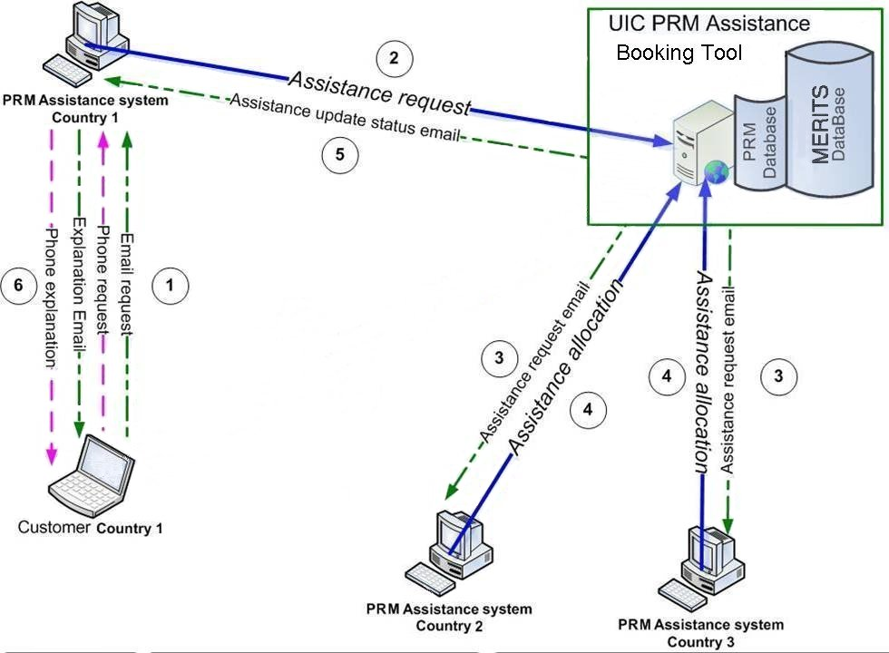

Those interested in more details about the UIC solution can write to:

”UIC • Passenger Department • 16, rue Jean Rey • 75015 Paris • France"

or make use of the contact form on [www.uic.org](http://www.uic.org).

# 9 Data quality

## 9.1 Quality requirements

The quality of the assistance booking exchanges presents two types of requirements:

* Correct use of codes

All elements included in the B.10 XML messages must be valid data, both in terms of codes contained in the directory of code lists, and in terms of reference data such as company codes and location codes.

* Correct interaction between systems

The exchange of XML messages between the assistance requester and the assistance allocator(s) must comply with the syntax defined in B.10 and the transmission protocols agreed by the partners.

Another element that can be considered in wide sense part of the data quality is the privacy. The booking of assistance requires the exchange of personal data of the PRM requesting assistance, like name, age, type of disability.

These are sensitive data and their use and distribution must be strictly controlled (see Directive 95/46 of 24.10.1995 on the protection of individuals with regard to the processing of personal data and on the free movement of such data). Both the assistance requester and the assistance allocator(s) must put in place all measures to keep those data protected while in use, and to completely cancel them after use.

## 9.2 Compliance tests

When an actor puts in place or renews a system for the IT request or allocation of PRM assistance it is necessary to conduct a complete and careful campaign of compliance tests, before putting it in service.

There is no established and standardised set of compliance tests. The actor must prepare a test campaign in agreement with all other actors with whom it intends to exchange assistance requests/replies.

The test campaign must include all different normal operations (request/reply of assistance, booking cancellation/confirmation of cancellation) and error cases (negative answer of the partner, negative answer of a partner when others had already confirmed, wrong request/answer, time out, etc.)

The test cases should be explained in this document. There should be a definition of a given set of test cases (with preconditions, expected results) – including failure test cases - to ensure the interoperability of the message exchange.

# 10 Governance aspects

## 10.1 Organisational steps for an actor to start sending PRM assistance requests

1. An actor (RU or third party) who intends to start sending PRM assistance requests via IT must have first of all an agreement with one or more assistance allocators (RUs, IMs or SMs) to whom it wants to send the requests.

The agreement with the allocator(s) must at least state the type of disabilities that can be assisted, the stations where the assistance can be requested, the network addresses where the requests and replies must be transmitted, the working hours of the application. The allocator(s) can require the performing of a test campaign to check the compliance of the actor’s system for assistance request.

1. The actor must contact the Governance Entity, who attributes to it an identification code (company code for RUs and IMs, registration code for third parties) code (if not yet attributed) and offers its services, according to a Chart Agreement to be signed between the two.
2. The Governance Entity makes available to the actor services such as:
   * The Regulation, Technical Documents and Implementation guides
   * Reference data (country codes, company codes, location codes, different code lists)
   * Registry (locations of resources, notifications of changes,..)
   * Etc.
3. Any actors must subscribe to the TAP Registry to get notified of any change in the timetables of the RUs for whose trains it intends to request assistance.

## 10.2 Organisational steps for an actor to start receiving PRM assistance requests

1. An actor (RU, IM or SM) who intends to start receiving PRM assistance requests via IT must contact the Governance Entity, who attributes to the actor a company code (if not yet attributed) and offers its services, according to a Chart Agreement to be signed between the two.
2. The Governance Entity makes available to the actor services such as:

* The Regulation, Technical Documents and Implementation guides
* Reference data (country codes, company codes, location codes, different code lists)
* Registry (locations of resources, notifications of changes,..)
* Etc.

1. Upon receiving from another actor a proposal to establish an exchange of requests, it negotiates with them an agreement. The agreement with the requester must at least state the type of disabilities that can be assisted, the stations where the assistance can be requested, the network addresses where the requests and replies must be transmitted, and the working hours of the application. The parties can agree the performing of a test campaign to check the compliance of both systems for assistance request and reply.

For all other governance information of general character, that can apply to all Implementation Guides, see the “TAP Implementation Guides Overview”.

# Appendix A - Glossary

|  |  |
| --- | --- |
| Term | Explanation |
| ABT | Assistance Booking Tool |
| Baseline | A stable kernel of interrelated legal and technical documents, in terms of system functionality, performance and other non-functional characteristics |
| Carrier | Contractual carrier with whom the passenger has concluded the contract of carriage pursuant to the CIV Uniform Rules, or a successive carrier who is liable on the basis of that contract |
| CCM | Change Control Management - the process by which the TAP TSI Regulation and its related documents can be modified during their life |
| Customer | Means a person who intends to buy, is buying, or has bought a railway product for him/herself or for other person(s). May therefore be different from passenger (see passenger) |
| Deliverable (TAP -) | One of the documents that must be produced as result of TAP Phase One |
| Distributor | Undertaking providing legal and technical capacity to the issuing undertaking to sell rail tickets or to provide on line-facilities to passengers to buy rail tickets. At the same time the undertaking may be a sales point, attributor, carrier, issuing undertaking and/or ticket control organisation (TCO) |
| ERA | European Railway Agency. According to Regulation (EC) No 881/2004 of the European Parliament and of the Council of 29 April 2004 establishing a European Railway Agency. |
| IG | Implementation Guide |
| IM | Infrastructure Manager |
| Issuing undertaking | Undertaking concluding the contract of carriage on its own behalf or in the name of and for the account of another carrier which issues the ticket and receives the payment. The issuing undertaking is indicated on the ticket with its UIC code and, where appropriate, its symbol. It may at the same time be a sales point, attributor, carrier, distributor and/or ticket control organisation (TCO). The term “issuer” is not to be used |
| IT | Information technology |
| Passenger | Means a person who intends to make, or is making, or has made a journey using the transport services and other services of one or more railway undertakings May be different from customer (see customer) |
| POS | Point of Sale |
| PRM | Person with Reduced Mobility |
| PRR | Regulation (EC) No 1371/2007 of the European Parliament and of the Council of 23 October 2007 on rail passengers’ rights and obligations. PRR GCC-CIV/PRR |
| RU | Railway Undertaking |
| Station manager | Organisational entity in an EU Member State, which has been made responsible for the management of a railway station |
| Successive carrier | Carrier in a chain of carriers who perform the contract of carriage with the passenger and who are liable for the performance of that contract. Successive carriers are shown in code on tickets |
| TAP TSI | Telematic Applications for Passenger services - Technical Specifications of Interoperability |
| Governance Entity | A regulatory entity for the governance of the telematics TSIs (TAP TSI and TAF TSI) This entity will address both RU/IM and passenger retail business. It will procure and provide the services needed by TAP TSI and TAF TSI stakeholders without which RUs and IMs cannot meet their regulatory obligations. The entity will facilitate the work needed in common amongst RUs and IMs |
| TD | Technical Document |
| Travel agent | A point of sale for railway tickets to passengers accredited by the carrier |
| UIC | International Union of Railways [Union internationale des chemins de fer] |
| XML | eXtensible Markup Language (XML) is a markup language that defines a set of rules for encoding documents in a format that is both human-readable and machine-readable. It is defined in the XML 1.0 Specification produced by the W3C, and several other related specifications all gratis open standards |
| XSD | XML Schema Document—a document written in the XML Schema language, typically containing the "xsd" XML namespace prefix and stored with the ".xsd" filename extension |