**TARIFFS IT SPECIFICATIONS**

|  |  |
| --- | --- |
| **Project:** | **TAP Phase One** |
| Release: | 1.0 – To DG MOVE, ERA, TAP Steering Committee |
| Date: | 13 May 2012 |
| Author: | Ugo Dell’Arciprete (Work Stream Leader) |
| Owner: | TAP Phase One Project Team |
| Client: | DG MOVE, ERA |
| Document Ref: | Tariffs IT Specifications |
| Version No: | 1.0 |

# 1 Progress History

## 1.1 Document Location

This document will be uploaded to the “TAP TSI/TAP Retail activities/Tariffs _ Fares (EG T)/ Working documents/IT Specifications” folder of the project extranet (members’ area).

## 1.2 Revision History

**Date of delivery: 13 May 2012**

|  |  |  |  |
| --- | --- | --- | --- |
| **Revision date** | **Previous revision date** | **Summary of Changes** | **Changes marked** |
| 2012.01.07 |  | First issue | None |
| 2012.02.19 | 2012.01.07 | Chapter 4, part of 6 |  |
| 2012-02-27 | 2012.02.19 | Chapters 6.2 and 10 developed |  |
| 2012-03-11 | 2012-02-27 |  |  |
| 2012-03-31 | 2012-03-11 | Changes in ch. 5,6,7,9,Appendices |  |
| 2012-04-14 | 2012-03-31 | Developed 6.3 and 7 |  |
| 2012-04-24 | 2012-04-14 | Ch. 7.2, 8, appendices A, B, C |  |
| 2012-04-25 | 2012-04-24 | Ch. 6.4, 9.2.4, appendix D |  |
| 2012-05-10 | 2012-04-25 | Glossary completed, general review |  |
| 2012-05-13 | 2012-05-10 | Final editing |  |

## 1.3 Approvals

This document requires the following approvals.

|  |  |  |  |  |
| --- | --- | --- | --- | --- |
| **Name/ Entity** | **Title/ Remark** | **Approval** | **Date of Issue** | **Version** |
| Project Team | Project Manager, Work Stream Leaders, Project Assistant | Done | 11 May 2012 | 1.0 |
| TAP Steering Committee | Chairs, members and alternates |  | 15 May 2012 | 1.0 |
| ERA |  |  | 13 July 2012 |  |

## 1.4 Distribution

This document is distributed to:

|  |  |  |  |
| --- | --- | --- | --- |
| **Name/ Entity** | **Title/ Remark** | **Date of Issue** | **Version** |
| DG MOVE, ERA | Official recipients of the TAP Phase One deliverables | 13 May 2012 | 1.0 |
| TAP Steering Committee | Chairs, members and alternates | 13 May 2012 | 1.0 |
| Project Team;  UIC and Ticket Vendor project coordinators | All members of the Project Team and the coordinators involved in the Grant Agreement between DG MOVE and UIC | 13 May 2012 | 1.0 |
| Interested public | On http://tap-tsi.uic.org | tbd |  |

## 1.5 Document maintenance

This document is maintained by the European Railway Agency .

Any stakeholder detecting errors or needing clarifications can contact the European Railway Agency (TAP_TSI@era-europa.eu).

Proposals for additions or updates can be sent to the same mail addresses, and will undergo the Change Control Management process described in the TAP regulation.

# 2 Table of Contents

1 Progress History 2

1.1 Document Location 2

1.2 Revision History 2

1.3 Approvals 2

1.4 Distribution 2

1.5 Document maintenance 3

2 Table of Contents 4

3 Purpose 6

4 Background documents 7

5 Rights & obligations, actors 8

5.1 Rights and obligations 8

5.2 Actors 9

6 Content of data 11

6.1 NRTs 11

6.2 IRTs 17

6.3 Special offers 25

6.4 Locations data 32

7 Process 35

7.1 How to make data available 35

7.2 Challenges of the liberalisation 42

8 Current situation 43

8.1 NRTs 43

8.2 IRTs 43

8.3 Special Offers 43

9 Data quality 44

9.1 Security rules 44

9.2 Quality checks 44

10 Governance aspects 46

10.1 Organisational steps for RUs to get started 46

10.2 Organisational steps for Third Parties to get started 46

Appendix A - Glossary 48

Appendix B) - Data display examples 51

B.1 NRT fares 51

B.2 IRT fares 52

Appendix C) - Data quality checks 54

C.1 Checks on file sets for NRT tariffs according to TD B.1 54

C.2 Checks on file sets for IRT tariffs according to TD B.2 57

C.3 Checks on file sets for Special Offers according to TD B.3 60

Appendix D) - XML messages 61

D.1 Sample from “Company.xml” 61

D.2 Sample from “country.xml” 61

D.3 Sample from “primaryLocation.xml” 61

D.4 Sample from “subsidiaryCodes.xml” 62

D.5 Sample from “subsidiaryLocation.xml” 62

# 3 Purpose

Regulation 454/2011 requires at the end of Phase One the issuing of deliverables on three areas:

* detailed IT specifications
* governance
* master plan

In particular “The detailed IT specifications shall describe the system and shall indicate in a clear and unambiguous manner how the system fulfils the requirements of the TAP TSI. The development of such specifications requires a systematic analysis of the relevant technical, operational, economic and institutional issues that underpin the process of implementing the TAP TSI. Therefore, deliverables shall include, but shall not be limited to, the following:

1. Functional, technical and performance specifications, the associated data, the interface requirements, the security and the quality requirements.

2. The outline of the global architecture of the system. It shall describe how the requisite components interact and fit together. This shall be based on the analysis of the system configurations capable of integrating the legacy IT facilities, while delivering the required functionality and performance.”

The purpose of this document is to provide specifications, in addition to what is already stated in the TAP itself and its accompanying Technical Documents (TDs), in order to facilitate all stakeholders involved in the TAP process, and in particular in the tariffs data exchange, to correctly fulfil their obligations or assert their rights.

Since the TAP Basic Parameters and Technical Documents have been established largely on the basis of the current way of operation of the incumbent European RUs, the specifications of this document are intended mainly for the use of the RUs entering the market (“newcomers”) and of the small RUs and RUs that are not members of rail sector representative bodies.

Nevertheless part of the specifications will benefit all RUs, including the incumbent ones, in fulfilling the new requirements introduced from scratch by the TAP TSI.

At the same time, this document intends to give detailed specifications on how third parties identified by the TAP as legitimate users of the data can access them, from a technical and organisational point of view. The TAP TSI provides the framework for future enhancements of data exchange between RUs and/or Third Parties.

Chapter 8 “Current situation” provides an overview, for information purpose only, on how the subject is currently managed by the main European RUs, in case a new or smaller Ru would like to adopt the same solution. Of course the only legal obligation remains the compliance with TAP TSI.

# 4 Background documents

The documents one has to know to implement the obligation to make available tariff data according to TAP are:

* Directive 2008/57/EC on the interoperability of the rail system within the Community (repealing Directives 96/48/EC and 2001/16/EC from 19 July 2010).
* Commission Regulation (EU) No 454/2011 of 5 May 2011 on the technical specification for interoperability relating to the subsystem ‘Telematics applications for passenger services’ of the trans-European rail system - Basic parameter 4.2.2
* TAP TSI: ANNEX B.1 - Computer Generation and Exchange of Tariff Data Meant for International or Foreign Sales – Non Reservation Tickets; Reference ERA/TD/2009-04/INT
* TAP TSI: ANNEX B.2 - Computer Generation and Exchange of Tariff Data Meant for International and Foreign Sales – Integrated Reservation Tickets (IRT); Reference ERA/TD/2009-05/INT
* TAP TSI: ANNEX B.3 - Computer Generation and Exchange of Data Meant for International or Foreign Sales – Special Offers; Reference ERA/TD/2009-06/INT, Version: see at http://www.era.europa.eu/Document-Register/Pages/TAP-TSI.aspx
* TAP TSI: ANNEX B.8 - Standard Numerical Coding for Railway Undertakings, Infrastructure Managers and Other Companies Involved in Rail-Transport Chains; Reference ERA/TD/2009-11/INT
* TAP TSI: ANNEX B.9 - Standard Numerical Coding of Locations; Reference ERA/TD/2009-12/INT
* Directory of Passenger Code Lists for the ERA Technical Documents used in TAP TSI; Reference ERA/TD/2009-14/INT
* TAP IT Specifications Overview Version 1.0
* TAP Retail Architecture Description Version 1.0
* TAP Governance Proposal Version 1.0

The above documents can be downloaded from the website of the European Rail Agency at <https://www.era.europa.eu/Document-Register/Pages/TAP-TSI.aspx>.

# 5 Rights & obligations, actors

## 5.1 Rights and obligations

The TAP sets an obligation for each RU to make available to certain actors all its tariffs (including fare tables) for the transport services operated by it.

### Who?

The obligation is on the European licensed RUs.

For trains operated by a single RU (sole carrier in TAP glossary) the obligation is on that RU.

For trains operated by a chain of successive RUs (joint carriers in TAP glossary) the obligation applies differently depending on the type of pricing used for the train:

* For trains sold as NRT (see 6.1), where the price is calculated as sum of national price components for international or foreign sales, the obligation is on each RU for the part of journey operated by that RU;
* For trains sold as IRT (see 6.2), where the prices are global and agreed by the carriers grouped under a single brand in what is called an Entity in TD B.2 (e.g. Thalys, Elipsos), the obligation according to TD B.2 is on the “network where the product and trains are managed”. Since IRTs, as the name says, are necessarily subject to reservation, the RU in question is to be considered the one acting as attributor for the concerned trains. This RU must ensure, together with all the other joint carriers, that the tariff data are accurate and up-to- date.

### To whom?

The Basic Parameter 4.2.2 of the TAP is not clear on this point, and uses different wordings to describe to whom the tariff data must be made available.

In a general way the concerned subjects are other railway undertakings, authorised public bodies and third parties, but the text of BP 4.2.2 contains expressions like “authorised to sell according to distribution agreements” or “to which it [*the RU*] grants authorisation to sell according to distribution agreements”, and it is not yet finally decided to whom refer these limitative expressions, whether only to third parties or also to RUs.

The right of authorised public bodies to access the tariff data is on the other hand undisputed.

The tariff data will be made available in non discriminatory way, with the same timeliness and accuracy, to all actors having unconditional access, while the others will only have access to those tariffs that they are authorised to sell according to distribution agreements.

The RU has the right to know who is the receiver of its own tariff data and which is the intended use of the data: this will be ensured through the registry described in the document “TAP Retail Architecture Description”. The RU as the owner of the tariff data is allowed to require a formal contract with the receiver of the data, even if the latter has right to unconditional and free access.

### Which tariffs?

The provisions of BP 4.2.2 apply in respect of all passenger tariffs of the RU for domestic, international and foreign sales. Nevertheless the standards described in the Technical Documents referenced in the current version of the TAP only cover the exchange of tariffs for international and foreign sales. The standards for the exchange of domestic tariffs are at the moment an open point and as such are not subject at present stage to the TAP tariff exchange.

### In which way?

The TAP only obliges the RUs to make available their tariffs, not to send them to anybody. Therefore it is sufficient to store the data in a server, making known where it is and how it is possible to access to the data. Hints on how to fulfil this task are given in chapter 9 - Architectural aspects, and more details in the TAP Retail Architecture Description

### When?

For NRT tariffs the data described in TD B.1 must be made available 3 months before they enter into force.

For IRT tariffs and special offers the data described in TDs B.2 and B.3 must be made available according to their sales conditions.

There is no requirement to keep the tariff data after their expiry.

### What?

The TAP glossary makes a difference between Tariffs and Fares.

The tariffs represent terms and conditions for the sale of rail tickets, and present a relative stability. A tariff can be created at any moment, but normally once created its conditions remain unchanged during some time, at least as long as necessary for the salespersons to acknowledge the new tariff and be able to sell it. Therefore there are in principle no problems for an RU to make available its tariffs.

The fares represent (as attribute of the Tariff) the price to be paid for a ticket. In the case of yield managed fares, the fare for a same ticket can change dynamically, according to algorithms based on many commercial factors. If the fare can only assume one of a limited set of predefined levels (“booking classes”), the standards described in TD B.2 and B.3 allow the RU to publish all those fares. If the fare can vary continuously within a range, the RU can only publish the minimum and maximum values.

## 5.2 Actors

The actors in the domain of tariff data exchange are mainly the RUs, in the many different roles they can play.

As carrier, an RU can be (see definitions in the glossary):

* Contractual carrier
* Principal carrier
* Substitute carrier
* Successive carrier
* Joint carrier
* Sole carrier
* Participant in a business unit (or entity).

As company subject to TAP, an RU can be:

* Data provider
* Information provider
* Reservation provider
* Resource provider.

On the other side the RUs, as well as third parties or authorised public bodies, can benefit of the tariff exchange system as;

* Data user
* Resource consumer

# 6 Content of data

The TAP takes into account three types of tariff data, to which three separate Technical Documents are dedicated:

Tariffs for NRTs in TD B.1

Tariffs for IRTs in TD B.2

Tariffs for Special Offers in TD B.3

Indications for the three cases are given in the next three chapters.

## 6.1 Non-integrated reservation tickets (NRT)

The NRTs have been the first method used for international or foreign sales, since the middle of twentieth century. In a time when computers and data transmission were not yet there, the only way to produce such tickets was writing them by hand, and all information needed to do so had to be available locally for the concerned salespersons.

On the other side, at that time in the rail sector there was no liberalisation and competition, and almost all RUs were in a two-way correspondence with a nation: DB was “the” German railway, FS “the” Italian railway, and so on.

Therefore to sell international tickets the rail community defined a mechanism where each RU took care of its own national territory, identifying a certain number of Origin/Destination routes (O/Ds) on it, and defining a rather simple way to attach to each of those routes a price. The price had very few alternatives : first or second class, adult or child.

Since the O/Ds (called “series”) could link two stations in the national territory, but also a station with a border point with a neighbouring Country or two border points, it was possible to create an international ticket by just adding the two national series in a single ticket, and calculate the price of the entire ticket as the sum of the two national parts.

In a similar way, in order to sell in one Country a ticket for an internal journey inside a foreign Country, it was sufficient to use the series and price tables of the RU of the foreign Country to issue a valid ticket (called in this case “section coupon”).

The series and price tables were initially printed by each RU in thousands of copies and distributed to the partner RUs participating in this agreement (called TCV : Tarif Commun Voyageurs), to be forwarded to each sales office allowed to issue international tickets. Later of course the printing was replaced by electronic transfer of data, and some extensions were introduced to allow for more flexibility, but basically the system has remained the same. How it is implemented today in practice is described in chapter 8.

### 6.1.1 Logic of B.1 and its tables

All data of B.1 must be made available in the form of flat files, with records of fixed length. The appendices A to K of B.1 show in detail the record structure of each file. Some files, those described in appendices A to G and K, can be present only once in each B.1 data delivery, while the files with fare tables, described in appendices H to J, can be repeated more than once. For this reason the files of the first type receive a fixed name (TCVx, where x can be G, S, M, T, O, C, P), while the files of the second type receive a sequential numeric identifier of 4 digits, with first digit different from zero (e.g. 10010081, for a price file of ÖBB).

The relations between the different files are shown in the following scheme:

B.1 data model.emf

A file must be made available only if it contains data: if e.g. an RU does not provide series info according to appendix C of B.1, it must not make available the file TCVM. Only files with changes versus the previous year (plus the header) must be made available necessarily, as well as files whose previous year’s validity has expired. Anyway all files can be made available anew even if there are no changes.

Since it is possible to not make available one or more of the TCVx files, and there can be multiple instances of the fare table files, it is necessary to complete the delivery with a header file listing all other files contained in the delivery.

The process by which NRT data are made available is described in chapter 7.1.1.

The following indications only complement the explanations already provided in B.1, respectively in the general introduction and in some of the appendices, without repeating what is already there. Therefore for a good understanding of what follows it is necessary to already have a sufficient knowledge of B.1. The following indications include clarifications where the text of B.1 could be interpreted in different ways (indicated by lamp sc.jpg), or detailed IT specifications where the text of B.1 is not detailed enough to guarantee a full interoperability (indicated by finger s.jpg).

### 6.1.2 General remarks

* All data tables require in the first field the code of the supplying RU (sometimes called delivering or supplier RU). This code must always be the one of the RU making available the data: in case RU A makes available data also for RU B, the first field contains the code of A while the code of B goes elsewhere (e.g. field 24 of TCVS)

### 6.1.3 Specific remarks

* 2.5: for the sake of interoperability, not any Latin character set can be used, but only ISO 8859-1
* A.1 field 9: this field must be left always blank with three exceptions:
  + When the station is contained in one of the “station in route” fields of table TCVS (fields 42 to 56), the content of field 9 is used to create the whole route description of a ticket. It can contain at maximum the same name present in field 7 but, since for a long journey the whole route description can become long, and given the space limits on a ticket, it is recommended to use in field 9 a shortened name with as few as possible of the allowed 17 characters, possibly not exceeding 10. Of course the remaining positions must be filled with blanks
  + When the station is one referencing another station (see A.2.7), the field 9 must contain the 17-character name of the reference station
  + When the station is a border station, the field 9 must contain the 17-character name of the border point (same as in field 7)
* A.1 field 11: field currently not used with a common meaning, to be left set to zero unless used for special bilateral agreements (content ≠ 0 must be ignored and not considered an error)
* A.1 field 25: field currently not used with a common meaning, to be left blank unless used for special bilateral agreements (content ≠ blank must be ignored and not considered an error)
* B.2.1: the wording “In such cases, "0" may not be used and shall not authorise any interconnection” means that a value "0" in fields 7 or 11 means that those departure or destination stations cannot be used to interconnect series
* B.2.2: “the station appearing first in the 17-character station description” refers to the station appearing first in alphabetical order
* B.2.2: specialty: If the departure or destination station is a fare reference station, the value "17-character route description" will be used for the name of departure or destination station for ticketing according to TD B.6 or B.7.
* B.2.8: the field 26 contains the route description of a series as a whole; the fields 42 to 56 contain the single elements that allow creating the same description via software. The RU making available the B.1 data must fill up correctly both field 26 and fields 42 to 56. The RU using the B.1 data to establish an NRT ticket is free to use any of the two systems.

The content of field 26 and fields 42 to 56 is provided by the RU making available the B.1 data with reference to the nominal departure and destination stations of the series A and B. The RU using the B.1 data to establish an NRT ticket is responsible for reversing the order of the route when establishing a ticket from B to A

* A special clarification is needed to explain the concept of optional routes.

A journey between stations A and D indicated on the ticket with the route description (B/C) does not mean that the passenger must take a train passing exactly by either B or C, it means that the passenger has a choice of all routes between a “tariff border” of a station on the left and a station on the right (route range).

For example, if the rail network is very interconnected, the situation could be as in the following figure:

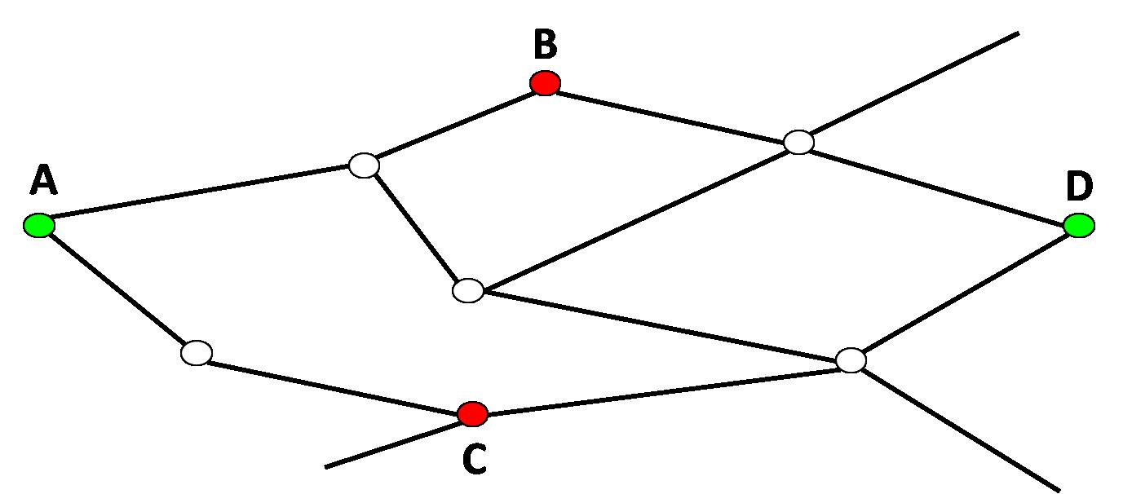

A ticket A > D with route description (B/C) would allow travel along any of the following routes:

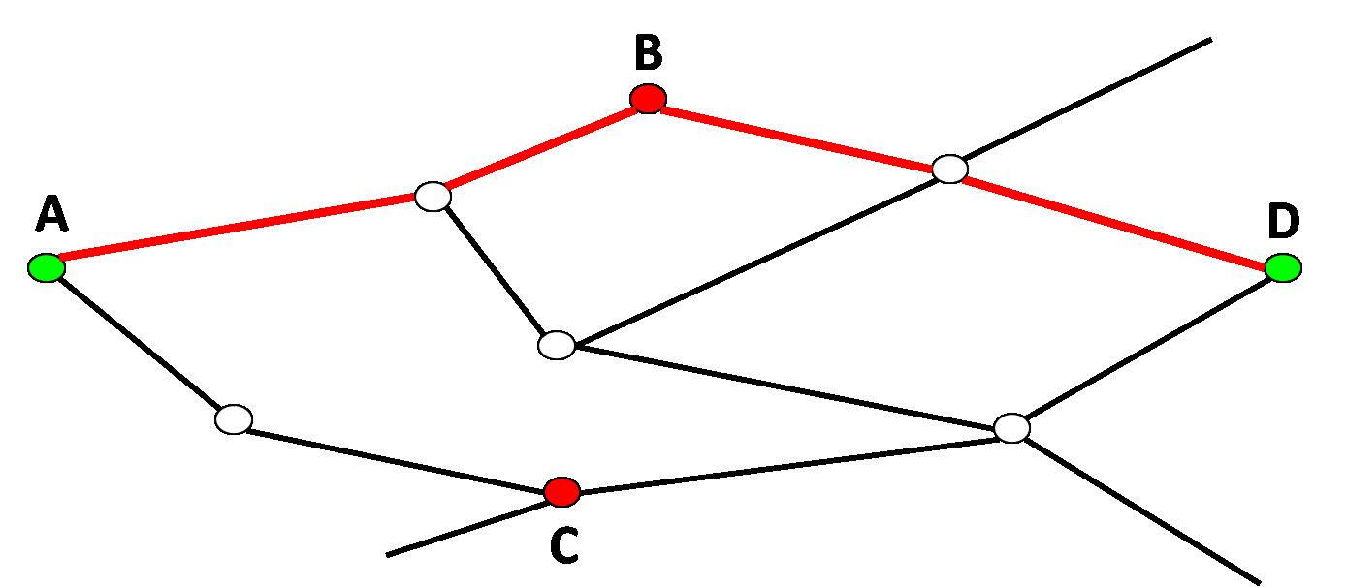

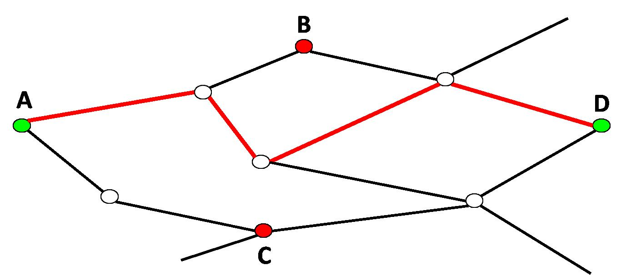

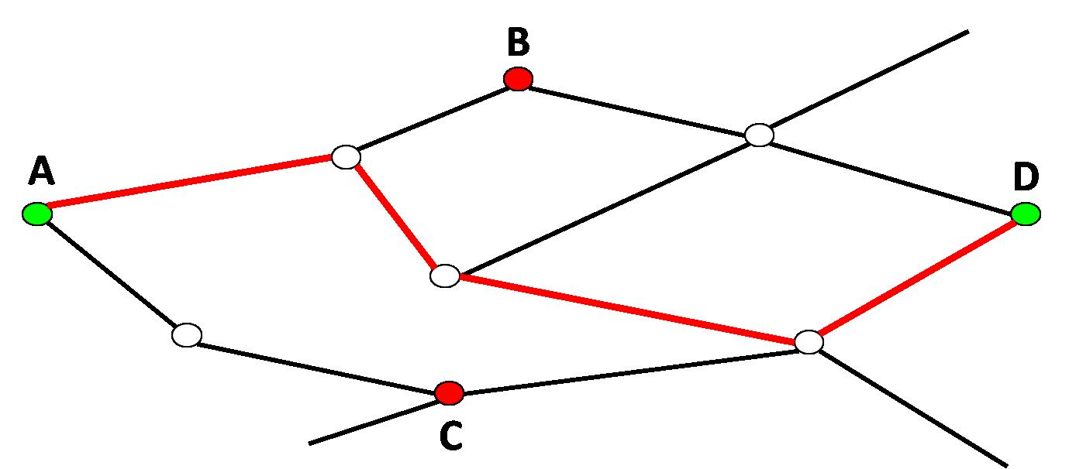

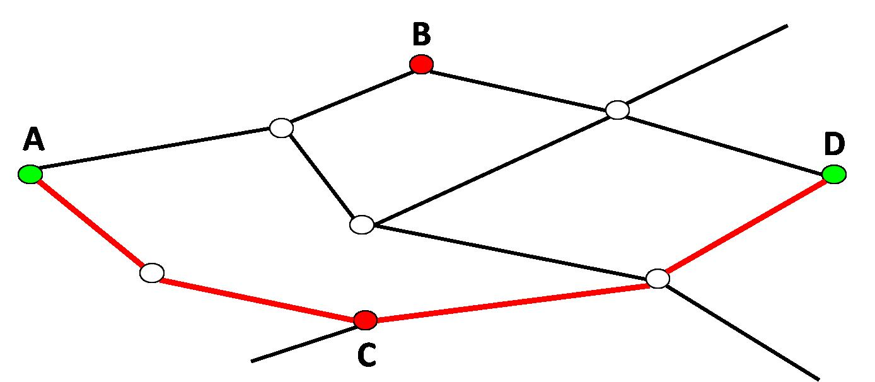

* B.2.15: the following examples help to clarify the meaning of codes 1, 2 and 3 referred to the position of a station in the route description :

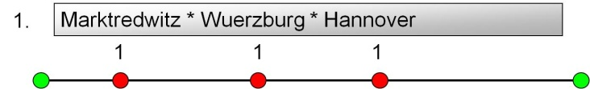

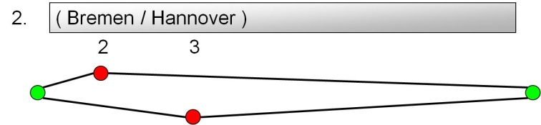

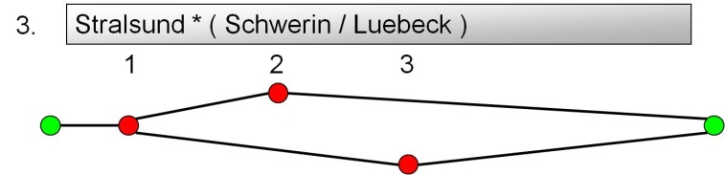

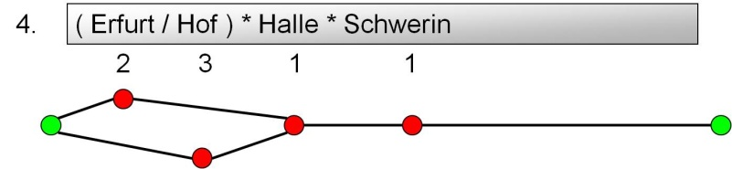

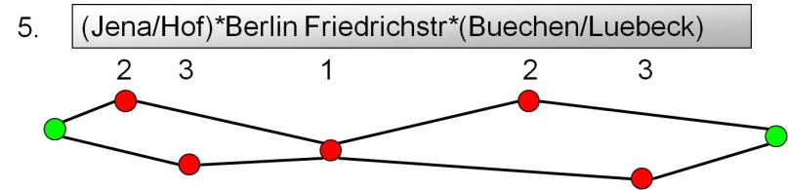

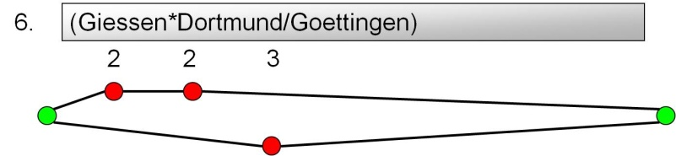

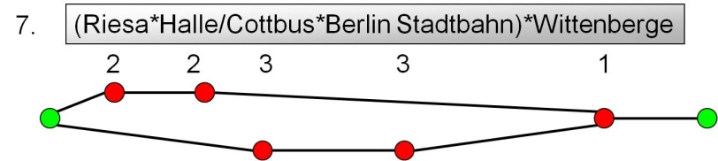

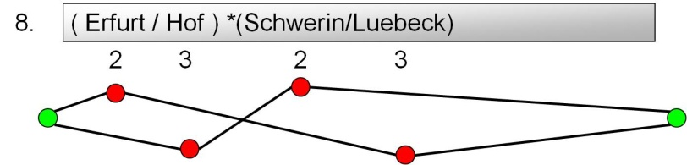

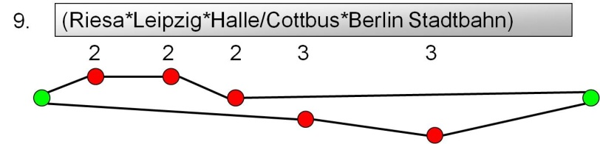

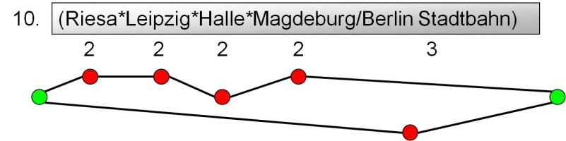

* E: entire table currently not used, not to be produced
* F.1 fields 6 to 14: the RU making available the B.1 data must input in these fields the address of its department competent for the NRT subjects (e.g. compensation requests for delays). This address is often different from the address of the RU’s Headquarters, contained in the Companies reference database
* F.1 field 16: field currently not used, to be left set to zero
* G.1 field 4: This field indicates which format has the fare table :

1 = distance based (fare table compliant with Appendix H of B.1)

2 = route based (fare table compliant with Appendix I of B.1)

3 = set fare (fare table compliant with Appendix J of B.1)

* G.1 field 10: Flag 1 must be set to “3” when anyone of the fields 5 to 8 has been modified versus the previous version
* G.1 field 13: This field indicates how to use the fare table :
  + 01 = TCV full fare = the fare for a full flexible ticket.
  + 02 = distance based fare = fare for using as offer fare (without offer conditions, see B.3)
  + 03 = market fare / global fare = is a reserved value, because these fares will be set in B.2
  + 04 = group fare = fare for using as offer fare for groups (without offer conditions, see B.3)
  + 05 = surcharges = in combination with another ticket, same like 06 = supplements
  + 06 = supplements = in combination with another ticket, same like 05 = surcharges
* G.1 field 14: this field must be filled up with 1 = yes if the fare for a return ticket is the double as the fare for a single ticket. In this case of course in the fare tables the fields with fares for return tickets (e.g. Distance based fare table, elements 9 and 11) must contain a fare double of the fare in the fields for single tickets (elements 5 and 7). Therefore the field 14 of G.1 is there to facilitate the task of the actors having to use the tariff data of an RU, value 1 means that the actor does not have to read the fare table 2 times (once for single tickets and 2nd for return tickets). It may just double the fare of a single ticket. On the contrary, if the value is 0 = No, the fare may not be doubled.
* G.1 field 21: this field can be used to indicate that a fare table of a previous version must be completely discarded, instead of repeating the same table with all lines having the key flag set to “2” (record deleted).

Examples on the use of the NRT data to calculate the fare to be paid by the customer are given in Appendix B.

## 6.2 IRTs

Integrated Reservation Tickets, in short “IRT”, are a specific type of tickets necessarily linked to a specific train on a specific date/time with a specific tariff. The acronym IRT is also commonly used (as well as the term “Global prices”) to identify the type of pricing under which these tickets are sold. An IRT can only be sold by means of an online transaction (see document “Reservation IT Specifications”) between a reservation system acting as requesting system on the retailer’s side and the reservation system of the product owner where the relevant train is hosted, acting as attributing system.

The situation concerning the reservation can be summarised as follows:

* Trains without reservation: trains sold at NRT pricing, where it is not possible to reserve a seat (typical situation for suburban and regional trains)
* Trains with optional reservation: trains sold at NRT pricing, where the passenger can reserve a seat if he/she wants to be sure of travelling seated
* Trains with mandatory reservation: trains sold at NRT pricing, where the passenger must necessarily buy a seat reservation, besides the ticket
* Trains with integrated reservation: trains sold at IRT pricing, where the passenger buys ticket and reservation together, with no evidence of separate prices.

Some trains can belong to more than one of the above categories depending on who sells the tickets, or can have part of the coaches sold under one reservation principle, and others under another.

While the NRTs, as indicated in 6.1, have been the first form of international rail ticketing, and for this reason based initially on paper exchanges, the IRTs have been introduced in the 80’s, when the experience gained with the “simple” seat reservation, complementing the NRT sales, indicated that the IT systems were ready to do more.

Some RUs, inspired by what the airlines were already doing, developed sales systems which adopted the typical airline concept of booking classes and dynamic pricing. This allowed overcoming many of the problems presented by NRTs:

* It was possible to modify the prices any time, instead of once per year
* It was possible to define the prices based on a multitude of criteria (day of the week, hour of the day, presence or not of competitors, etc.), instead of the uniform application of kilometric prices
* It was possible to create special prices for time limited market offers (romantic weekends, football matches, art exhibitions, etc.) or dedicated to target groups (youth, business, etc.)
* It was possible for the Product Owner, to know instantaneously and to optimize the revenue on its train, as prices were given by itself, at booking time by its Reservation system. De facto, the Product Owner was in capacity to invoice the distributors, at the opposite of the NRT pricing.

The IRTs have rapidly been adopted by a large number of RUs, and in particular by those commercial entities created to exploit with a specific brand entire international routes, such as Thalys between France, Belgium, Netherlands and Germany, or Cisalpino between Switzerland and Italy. IRTs have also been introduced on many national products such as AVE in Spain or TGV in France (“single RU entities”). The importance of those entities is such that all data files of the Technical Document B.2 have the RU code and the entity code as first identifier.

To an IRT always correspond one tariff and one fare. According to the official TAP glossary tariff means “a specific set of fares available on a given train, on a given day for a given O-D leg of the journey. ...”, while fare means “a charge to be paid for transportation or service”.

A carrier or entity that wants to apply IRT pricing on its trains, must make available its tariffs and fares in a format compliant to TD B.2.

A distributor (other railway, third party, ...) who wants to know the tariffs and fares of a Transport Service applying the IRT pricing, has to retrieve them from the server of the corresponding carrier or entity: this will be ensured through the registry described in the document “TAP Retail Architecture Description”.

A combination of product and tariff describes the conditions of sale, the rules and restrictions to travel associated to this tariff, as well as the after sales conditions.

A same combination of product and tariff can have different levels of price, depending on the availability of seats, in different quotas, in the requested train (level of train filling).

As an example, Thalys Semi Flex tariff in comfort 1 fluctuates between 59 and 129 € through 5 levels.

A same combination of product and tariff can have different fares Peak / Off peak, depending of the period of circulation of some trains, e.g. rush hours / plain hours, working days / weekends. As an example, train number 2803 from Paris to Luxemburg, is Peak from Monday to Friday, when Loisir tariff costs 62 €, and Off peak the Saturday, when it is 49 €.

Level of price and periods can be mixed on a same train; it is the case of Paris to Luxemburg service.

Some carriers or entities (e.g. the Swedish carrier SJ) practice the “Dynamic pricing”; i.e. they change dynamically the price of tickets in function of the train profile and its filling level; for those cases, the RU can only publish the minimum and maximum values.

As the IRT tariffs are closely linked to the market, each carrier or entity, at any time, has the ability to modify its tariffs and/or its fares.

Any change on the tariffs themselves (adding a new tariff, modifying the rules of an existing tariff) has to be provided before start of the sales according to their sales conditions, in order to allow the retailer to correctly inform the customer.

Changes on fares, due to a price increase or reduction versus what had been made available in the B.2 compliant files have to be made available according to their sales conditions,.

In case of International Entities, or Joint Ventures, the update of the B.2 compliant files is the responsibility of the carrier managing the inventory of the trains, except if a bilateral agreement delegates it to another RU.

### 6.2.1 Logic of B.2 and its tables

Similarly to what happens for NRTs with B.1, also for B.2 all data must be made available in the form of flat files, with records of fixed length. The appendices 1 to 11 and 13 show in detail the record structure of each file (in the following the terms “table” and “file” will be equivalent). The files that do not contain data do not need to be made available (apart the files PCTA, PCPR, PCGA and PCET, which must always be present).

The process by which IRT data are made available is described in chapter 7.1.2.

The description and explanations of the products/tariffs are given in the annexes 1, 2, 3, 4, 5, 6, 9, 10, 11 of B.2.

Annex 7 presents the prices for each tariff per O/Ds or Zone or group of O/Ds.

Annex 8,8b present the Zones and the Groups of O/Ds used in Annex 7

The relations between the different files are shown in the following scheme (each file has also key fields RU and Entity that are in relationship, but they are not shown in the scheme for better readability):

B.2 data model.emf

#### Annex 1 Explanatory note on “Tariffs” :

This file gives the different elements that define the rules attached to a tariff/product, as:

* the railway and possibly the train category to which it belongs,
* its name, its numeric code, the kind of passenger ....
* sales dates, travel days, apex conditions....

Some of those rules can be controlled at time of reservation by the ‘Reservation System’ managing the relevant train (sales date and time, train category, apex....).

Some are informative rules controlled as a last resort by the TCO on board (age of the passenger, Card ownership ...).

Some elements in this file, cross-refer to other annexes of the B.2, to complete the description of the element.

* element 4 cross refers to annex 2
* element 21 to annex 3 which cross refers to annex 9
* element 27 to annex 4
* element 34 cross refers to annex 5 which cross refers to annex 10
* element 35 and 37 to annex 6
* element 38 to annex 11
* element 5: Tariff Number : is a number, unique per Entity, identifying a tariff in its finer definition. It is used from Annex to Annex to recognise this specific Tariff Number which have in Annex 7 a specific price.

It is a “technical number” used to assign to a same Tariff code different prices, with possibly different Annexes, but not necessarily.

Example: Business Adult with Tariff Code 72, can have 2 or 3 Tariff Numbers, depending on the Train Category, the Annex 3 assigning a different Memo, possibly a different After Sales conditions, and different price.

That is the case for SNCF, even with same Train Category, TGV, there are 2 “Annex 3” records to precise if it is a Peak period TGV or Off Peak Period TGV, and there are 2 “Annex 7” records with 1 price attached to both of the Tariff Numbers and same Tariff Code.

* Element 6: Tariff Code is on 2 digits.
* Element 22 + 23 Minimal and Maximal number of travellers, refer to the number of passengers that have to travel together to get the fare, between 1 and 99, although at reservation time, the maximum number of passengers cannot exceed a value depending on the type of accommodation (seats, couchettes, etc.).

Those limits can be pure commercial limits, as the RIT conditions which impose to the Tour Operator a certain number of passengers sold individually, or commercial and technical limits, as the DUO tariff in the public range, where the number of passengers is controlled at booking time through B5.

* Element 24 Travel Day + 25 Departure time from + 26 Departure time to, relate to the departure of the passenger on the train of the Entity.

#### Annex 2 Explanatory note on “Range” file:

This file, referring to element 3 of Annex 1, describes the Range number to which the tariff belongs. If some sales conditions of different tariffs belonging to a same Range, are identical (annex 3, 4, 5 or 6), they can be entered once at the Range level, for those tariffs.

Example: Code Range number 2, is the code for the RIT Range; all tariffs with this code 2 should be used only in case of travel included within a Rail Inclusive Tour.

Standard codes from 00 to 10 are listed in the “Code List” B.2.6.

Other codes can be decided by the entities. In this case the name of the range must be defined in the file.

The information on the association of a tariff to a specific range can help to display or not display the tariff on a web site. It can also be the solution to reserve a specific range of tariffs, for bilateral agreements.

#### Annex 3 Explanatory note on “Cards/memo” File:

File 3, referring to element 21 of annex 1, describes the Card(s) that the traveller should own, to get the specific tariff to which this annex is attached. It could precise also, if the Card should be valid for a specific country.

Element 5, Group, indicates if one or multiple Cards are necessary (or if one or multiple Memo are related).

* Value 0 means only one card has to be shown to benefit from the tariff
* Value 1 means “and”. All cards listed have to be shown.
* Value 2 means “or”. One of the listed cards has to be shown.

Element 6: the codes of the “Standard Card” are defined between 00 and 10; they are in the Code List B.2.7. Codes over 10 up to 99 can be used by the Entities for specific Cards.

In those cases the code gives the Card name or the text of the memo in the annex 9.

It is used for example as memo to distinguish PEAK and OFF PEAK fares for a same Tariff Code on a same train category or even on same train number.

Different Memo, can be used also to define for a same Tariff code, different tariff numbers to take into account different fare levels and enables to define the minimum and the maximum price.

Element 7: Country Code value is the one defined on 3 alpha of the ISO 3166-1 Standard.

This Annex is a pure informative Annex.

#### Annex 4 Explanatory note on Exclusion” File:

File 4 complements the element 27 of Annex 1, if Yes, to exclude a Train Category, a Train number, a Travel Period or travel days from the use of the specified tariff.

Those exclusions can apply solely, or can be mixed, to train category or train number for certain days or a period of circulation.

Element 7: Railway Code, no more in use, must be set to 0000.

Generally the controls of those “exclusions” are made at the Reservation System level, at booking time.

#### Annex 5 Explanatory note on “Sales Conditions” File:

File 5 describes the sales restrictions if specified in field 34 of Annex 1. It can be expressed as authorisation to a Railway or to a country or as exclusion. The restrictions can be detailed at the distribution channel level: channel codes 00 to 10 are used for standard channels (defined in Code list B.2.8), codes over 10 can be defined by the Entity in the Annex 10.

Element 6: Railway code is on 4 numerical characters, Country code is on 3 alpha characters (with a blank for the fourth character).

Usually, the Reservation Systems are able to control the “Sales Conditions” at railway level, but not at the country level nor at the channels level.

#### Annex 6 Explanatory note on “After Sales Conditions”:

File 6 details the After Sales conditions expressed in fields 35 and 37 of Annex 1.

For Exchange and Refund it is possible to define the period during which one of the after sale operations is possible, expressed in number of days/ hours before/after departure of the train. It’s related to the departure of the train from the passenger origin station.

Fees can be expressed as a fixed amount or as a percentage possibly restricted with a minimum/maximum amount.

Those after sales rules, are the ones applicable to the customers.

According to the Reservation Systems, and to the Distribution Systems, the fees defined in this annex, can be managed:

* by the systems through the TD B.5 (Reservation system returns the fees in the confirmation of cancellation message via B.5)
* locally by the distribution system itself, or it can be done “manually” by the retailer, after cancellation via B.5.

Please submit the CR, agreed on 22.03.12: “File 6 “After sales conditions”, change from 2 to 3 the length of elements 7 and 9”

#### Annex 7 Explanatory note on “Price” file:

This file contains the prices for each tariff of the RU or of the Entity.

Prices are given per O/D, or per group of O/D through the usage of ZONEs or GROUPs of O/Ds.

The Zones and Groups of O/Ds are described in Annex 8 and Annex 8b.

Element 15 “Single/Return”: if R is selected, the price in element 21 stands for a return journey.

As through TD B.5, there is no possibility today to book a return journey, nor is there a context of multi segments journey, it is at the moment useless to define return journey amounts. Even if a carrier wants to offer a return journey tariff, the price to enter in this annex has to be half of the return journey amount.

Element 17 “Journey Type”: if Indirect, means the price for the O/D applies with a change of train at the Via Code defined in element 18. As for element 15, since there is no multi segments context at reservation time, it is at the moment useless to use it.

Please submit these CR’s, agreed on 22.03.12: “change from 3 to 4 the length of element 19” and “change from O to M (mandatory) the nature of field 20”

#### Annex 8 Explanatory note on “Zone” file:

This file, complementing the elements 12 and 13 of annex 7, allows to list stations that can be grouped in order to use the Zone code as Origin or Destination, when prices are identical for all stations of this Zone. That enables to not repeat x times the same price in Annex 7.

There is no limitation of the number of stations belonging to one zone.

The name of the station is defined as 20 alphanumerical, but this length is not standard in the locations database. The 17 characters name must be used, with 3 trailing blanks

#### Annex 8b Explanatory note on “Grouped OD” file:

As Annex 8, the file complements the element 12 of annex 7 when “type of origin station” in element 11 is set to G. It enables to define in one group, all “Origin/Destination” station couples, which have the same price for the same product.

There is no limitation of the number of station couples belonging to one Group.

The name of the station is defined as 20 alphanumerical, but this length is not standard in the locations database. The 17 characters name must be used, with 3 trailing blanks

#### Annex 9 Explanatory note on “Name Cards/Memo” file:

The file specifies in 4 possible different languages (at least the local one) the name of the Card, or the text of the Memo created by the Entity, in Annex 3 element 6, with a code over 10.

#### Annex 10 Explanatory note on “Distribution” file:

This file allows an Entity to define specific distribution Channels not included in the standard ones with codes 0 ÷ 10 listed in the Code List B.2.8. Specific codes over 10 are chosen by the Entity and indicated in the Annex 5 – element 8.

#### Annex 11 Explanatory note on “Tariff Combination / Dynamic Prices From” file:

The file can be used, for information only, for 2 independent types of information:

* First one to advise the distributors of which tariffs can be combined together ( in case of multiple passengers with different tariffs), to be able to reserve in one transaction the passengers in order to place them close to each other , knowing the TD B.5 allows to book 2 tariffs in one message.
* Second usage, mentions the tariff Code linked to one tariff, with different price levels due to different quotas/dynamic fares. It informs the distributors, that those tariffs are similar, with same rules, but with different prices according to quotas. If a tariff code is not available through B.5, the other tariff code can be requested.

In this file, tariff code is defined on 3 digits although it is on 2 digits in annex 1 ,it is to anticipate future developments. The first digit has to be set to zero.

#### Annex 12 – Reference Table:

All reference tables are grouped in the “Directory of Passenger Code Lists for the ERA Technical Documents used in TAP TSI”

#### Annex 13 – Header File:

The file details the content of the header that has to include all information about files made available.

Element 1: for continuity reasons, the Version of Technical Document B.2 starts with Version 05.

The file is used at time of downloading, to check if all needed files are present.

Though Annex 13 defines an alternative format, for interoperability sake only the first format must be used.

Examples on the use of the IRT data to display prices are given in Appendix B.

## 6.3 Special offers

The standard described in TD B.3 was created to exchange in machine readable format the characteristics of the special rail offers. This refers specifically to offers based on the NRT pricing system, because in IRT pricing the creation of a new offer is very easy, with just the activation of a new tariff code and related sales and after sales conditions. On the contrary the NRT system described in B.1, with its use of fare tables only linked to the O/Ds, and with the need to publish data that remain valid one year, is not flexible enough to describe offers that could provide discounts different from just the basic ones (1st or 2nd class, adult or child), nor offers created outside of the rigid yearly scheme.

Therefore B.3 uses the same concept of series of B.1, has an identical structure for the price tables as B.1, and only provides additional data tables that allow to standardise the elements typical of special offers (distribution channels, exclusion time periods, discount cards admitted, etc.). It is to be noted that, while B.1 follows a territorial principle (each RU only makes available data relative to its country), in B.3 the RU making available the data of an offer does so for the whole route.

The standard of B.3, though created initially in the UIC framework, has never been used by any UIC member, partly because of its complexity and therefore implementation costs.

As a matter of facts, the offers to which B.3 is dedicated are created for specific markets, and so only the originating RU sells them. As an example, German customers can buy from DB an offer called Europa Spezial Österreich, for journeys to Austria and back, while Austrian customers can buy from ÖBB a similar but different offer called Sparschiene Deutschland for journeys to Germany and back.

It is to be noted that this is not an application of the liberalisation principle, with German trains running also on Austrian rails or vice versa; the trains are operated on the classical principle of consecutive carriers and the revenue of tickets is shared according to agreements between carriers, but the commercial offers are different. So on the same Germany to Austria train there can be German passengers on their outward journey with Europa Spezial Österreich, and Austrian passengers coming back home with Sparschiene Deutschland.

In application of this principle, for each offer there is an “owner” RU and one or more participating RUs. The “owner” RU in B.3 is called “transferor RU”, because in origin it had to transfer the data tables to the other involved partners. In view of the TAP, that only sets an obligation to make available the data locally, the transferor RU could be intended as the publishing RU. The participating RUs are the other carriers of the offer, apart from the transferor, and possibly other RUs allowed to sell the offer. It is also possible to designate in B.3 RUs that are not carriers and do not sell the offer, but are allowed to read its details. To all other RUs a special offer must remain hidden.

### 6.3.1 Logic of B.3 and its tables

Similarly to B.1 and B.2, all data of B.3 must be made available in the form of flat files, with records of fixed length. The appendices A to Q and T to X show in detail the record structure of each file.

Some files, those described in appendices A to Q and T to U, can be present only once in each B.3 data delivery, while the files with fare tables, described in appendices V to X, can be repeated more than once. For this reason the files of the first type have a fixed name, while the files of the second type have a sequential numeric identifier of 4 digits, with first digit different from zero.

The files of the first type are further divided in two subsets: the first one (A to Q) contains files specifically created for B.3, with names of the type OFxx, while the files of the appendices T and U are exactly identical to files already defined in B.1, and so they also keep the same names : TCVP (Fare table explanations) and TCV (Header).

A file must be made available only if it contains data: if e.g. an RU does not use for its offers memo elements according to appendix O of B.3, it must not make available the file OFME.

Since it is possible to not make available one or more of the TCVx files, and there can be multiple instances of the fare table files, it is necessary to complete the delivery with a header file listing all other files contained in the delivery.

The process by which Special offers data are made available is described in chapter 7.1.3.

The following indications only complement the explanations already provided in B.3, respectively in the general introduction and in some of the appendices, without repeating what is already there. Therefore for a good understanding of what follows it is necessary to already have a sufficient knowledge of B.3. The following indications include clarifications where the text of B.3 could generate doubts (indicated by lamp sc.jpg), or detailed IT specifications where the text of B.3 is not detailed enough to guarantee a full interoperability (indicated by finger s.jpg).

### 6.3.2 Remarks on the general introduction section, or common to more tables

* While B.3 only states that for the data provision a generic Latin character set must be used, for the sake of interoperability only ISO 8859-1 must be used.
* Connection between the tables

The connections between tables are clearly shown by the figure in B.3. The relations between the different files are shown in the following scheme:

B.3 data model.emf

The flags included in the OFCO file can be used to see immediately which other files are referenced by the current offer, and which are missing.

* Calculation of fare

The fare for a special offer made available in a B.3 delivery has to be calculated taking into account the different types of discounts listed in the tables. The discount structure is a hierarchical one, where the application of potential discounts must be checked in a specific order, as described in the following figure.

Based on the wishes of the customer, the offer to be calculated is selected through the offer conditions. For each offer, a separate fare table can be given on the basis of which the basic price is determined. Even if the maximum fare per person is exceeded, the maximum fare indicated for the offer will continue to be used in calculations.

If the normal fares table is indicated, the fare associated with the offer can be discounted by a percentage specified in the OFCO table (field 39).

If a passenger type (e.g. child) qualifies for a discount on the fare calculated for the offer, the discount is applied via the details set out in the OFPA table (field 5). To avoid having to search through the entire table, the OFCO table contains a flag to indicate whether passenger types are eligible for discounts for the offer in question.

If additional discounts such as for instance discount cards (e.g. ÖBB - Vorteilscard) are allowed by an offer, the details shall be specified in the OFAR table (field 5). A corresponding flag in the OFCO table will indicate whether additional discounts apply for this offer. It is possible to ascertain in the OFPA table, by means of a flag, whether an additional discount is allowed or not for each type of passenger. An adult for instance might be entitled to a discount on an ÖBB "Vorteilscard", whereas a child might not.

If a companion discount is available for an offer, the discount amount shall be entered in the OFFP table (field 5). A corresponding flag in the OFCO table will indicate whether companion discounts apply for this offer. It is possible to ascertain in the OFPA and OFAR table, by means of a flag, whether a companion discount is allowed or not depending on the passenger type and additional discount. It is therefore possible for instance to specify that an adult with an ÖBB Vorteilscard is entitled to the companion discount whereas a child in possession of an ÖBB Vorteilscard is not.

The following additional conditions apply to the companion discount:

The first person must always be the paying passenger with the lowest discount of the table OFPA, who can claim the highest discount of the table OFAR. The first person is not entitled to the companion discount. The fare is calculated per person. If the fare falls below the minimum fare, the minimum fare is charged. If during calculations the fare falls below the price floor or goes above the price ceiling, the calculation of the offer is aborted. It is possible to indicate whether the price thresholds apply to one person or all persons party to the offer.

NB: the above calculations must be performed separately per each participating carrier

**OFCO   
Conditions**

*Offer*

Series

Trains

Blackout periods

After-sales

Memo

Passenger type

Addtl. discounts

Companion

**Discount in %**

**OFOF  
Offer**

*Fare/supplement*

**OFFC   
Fare table per class**

*Offer class*

Fare table

Maximum- /  
minimum fare

**OFPA Passenger**

*Offer*

*Passenger type*  
Addtl. discounts (Flag)   
Companion (Flag)

**Discount in %**

**OFAR   
Additional discounts**

*Offer*

Companion (Flag)

**Discount in %**

**OFFP Companion**

*Offer*

**Discount in %**

**Flags**

No / Yes

No / Yes

No / Yes

**End price**

Flag-controlled access  
Calculation of fare

* Calculation of supplement

Supplements as well as offers are input separately in the data structure. To ascertain whether the data input concern supplements or a self-contained offer, the data input in the OFOF table are marked as offer or supplement.

The OFFS table can be used to assign an offer or supplement to any class of a train.

The offer and supplement prices are calculated separately and at the end added together to form the fare. The calculation logic is identical for offers and supplements.

If there is an obligation for reservation or in case the passenger wishes to have a reserved seat, then the reservation fee will be added.

The process for the calculation of the supplement is described in the following figure.

NB : the above calculations must be performed separately per each participating carrier

***Calculation of offer***

**Offer calculation***conditions*

D*iscounts*

**OFFS   
Fare and supplement**

*Train*

Class for fare

Class for supplement

**OFOF**

**Offer**

*Fare/supplement*

**OFFC   
Fare table per class**

*Offer* class

Fare table

**Travel request**

**Fare**

**Supplement price**

**End price**

**OFRT - reservation**

* Participating RUs

Many tables have a field labelled “Company code of participating RU” with a text in the Notes section stating “0000 = all RUs”. This means that the characteristics indicated in the record with “0000” apply by default to all RUs, with exception of those differently indicated.

For example in OFAT we can have:

|  |  |  |  |  |  |  |  |  |
| --- | --- | --- | --- | --- | --- | --- | --- | --- |
| ... | Company code of participating RU | ... | Personal sale | ... | Train attendant | ... | Read only access | ... |
|  | 1181 |  | Y |  | Y |  | Y |  |
|  | 0083 |  | Y |  | N |  | Y |  |
|  | 0000 |  | N |  | N |  | Y |  |

In this case ÖBB (1181) can sell the offer in station and on board, Trenitalia (0083) can only sell in station, all other RUs can only be informed of the offer but cannot sell it.

### 6.3.3 OFOF - Offer

* Field 5 : “Title of offer in country’s official language” means title in the language of the country where the transferor RU is based
* Field 15 : in case the whole O/D is travelled with more than one train, and more than one train is open to reservation (optional or mandatory), this field indicates if one or more reservations can be obtained without payment (but at least one is always paid)
* Fields 16 to 27 : the content of these fields must be equal to the content of field 4 in the various lines of the header

### 6.3.4 OFAT - Authorisation

* OFAT is the only table where under “participating RUs” is possible to indicate both the RUs participating as carriers of the offer, and RUs participating as distributors. In the following tables “participating RUs” only refers to the carriers

### 6.3.5 OFCO - Conditions of offer

* Field 5: this field is set to Y when the ticket is issued anonymous, therefore transferable from one customer to another, is set to N when the ticket must be nominative
* Fields 10 to 13

The period of validity starts from the first validity day that can be requested by the customer different from the date of purchase. The whole trip, including the return if present, must be concluded within the period of validity

* Fields 14 to 19

The method used to indicate the periods of validity can be used indifferently in positive (when travel is possible) and in negative (when it is not possible).

E.g. if travel is only allowed between 2pm of Friday and 2pm of Saturday it is possible to use any of the following descriptions:

|  |  |  |
| --- | --- | --- |
| Element 14 | Day of journey | N N N N N N N |
| Element 15 | Time from | 00 00 00 00 00 14 00 |
| Element 16 | Time until | 24 24 24 24 14 24 24 |

|  |  |  |
| --- | --- | --- |
| Element 14 | Day of journey | N N N N Y N N |
| Element 15 | Time from | 00 00 00 00 14 14 00 |
| Element 16 | Time until | 24 24 24 24 24 24 24 |

|  |  |  |
| --- | --- | --- |
| Element 14 | Day of journey | N N N N Y Y N |
| Element 15 | Time from | 00 00 00 00 14 00 00 |
| Element 16 | Time until | 24 24 24 24 24 14 24 |

|  |  |  |
| --- | --- | --- |
| Element 14 | Day of journey | N N N N N Y N |
| Element 15 | Time from | 00 00 00 00 00 00 00 |
| Element 16 | Time until | 24 24 24 24 14 14 24 |

* Field 40

If “N” is indicated, the price of the ticket will result exact to the euro cent, unless a rounding is applied after applying a subsequent discount

### 6.3.6 OFFC - Fare table per class

* Field 7

Since B.3 uses the same structure of fare tables as B.1, and B.1 only considers the regular 1st and 2nd class, it would be impossible to define fares for special classes that some RU uses, different from 1st and 2nd. The use of field 7 is a “trick” allowing to overcome this limitation, defining an additional fare table and indicating that in this new table the price in the field “1st class” is in reality the price for the class e.g. “Tourist” etc.

* Fields 8 to 11

Minimum, maximum, ceiling and floor have the following meaning :



* If the price, after application of all discounts, falls in zone 1, it is left unchanged
* If it falls in zone 2, it is forced to the value “minimum”
* If it falls in zone 3, it is forced to the value “maximum”
* If it falls in one of zones 4, the offer cannot be sold

### 6.3.7 OFNP - Number of passengers

* Fields 5 to 7

The field 7 indicates how many persons are granted free travel as benefit when accompanying a group. The table must be filled up with one row per size of the group, e.g.:

|  |  |  |
| --- | --- | --- |
| Minimum number | Maximum number | Free persons |
| 5 | 10 | 1 |
| 11 | 15 | 2 |
| 16 | 20 | 3 |

### 6.3.8 OFRE - Type of discount

* Field 8

In this field it is possible to insert an hyperlink to a page in a web site where a more detailed description of the discount type can be found (conditions of application, proof of applicability, etc.)

### 6.3.9 OFAR - Additional discount

* Field 4

The value of this field must correspond to the value of field 2 in one line of OFRE, where the nature of the discount is indicated

### 6.3.10 OFSE - Series

* Fields 3 and 4

It is possible for the transferor RU to include in table OFSE series operated by participating carriers in foreign countries. The series can even not be included in the regular B.1 delivery of the participating carrier, but only defined for the scope of the offer. E.g. Trenitalia does not publish the series “Brenner - Verona” in its B.1, because Trenitalia does not accept standard NRT tickets on that route, but provides bilaterally to DB a series number for that route to be used in Europa Spezial Italien

The series included in table OFSE can or cannot be used with the current offer, depending on content of field 30 in OFCO

### 6.3.11 TCVP - Fare table explanations

* In a B.3 delivery it is not necessary to have at least one fare table according to appendices V, W or X. If none of them is present, the calculations and the discounts are performed on the fare tables of the B.1 delivery of the corresponding RU. But in this case the file TCVP must be present in B.3, and must reference the fare tables of B.1

Additional chapter with hint to TLT (as “open point” to be included here ?

## 6.4 Locations data

The TAP states, in chapter 4.2.19.1, that:

“For the operation of passenger trains on the European network, the following reference files must be available and accessible to all service providers (infrastructure managers, railway undertakings, authorised third parties and station managers). The data must represent the actual status at all times.

The European Railway Agency will centrally store and maintain unique codes for the following reference data:

…

-- reference file of the coding of locations,”.

Those locations data (used within aforementioned NRTs, IRTs and Special Offers) will be centrally stored, and will be commonly used by all IT applications needing them (also for freight and infrastructure domains). This will avoid the risk of creating inconsistencies, especially considering that with the market liberalisation more than one RU will operate trains in the same station.

It has therefore been agreed that the locations database will be unique and centralised, procured by the Governance Entity (see document “Governance Proposal”), with different parts of the content defined by different actors (National Entities, Infrastructure Managers, Railway Undertakings) according to well defined governance rules.

When the locations database will be in place it will be possible for the Data Quality Management tool (see chapter 7.1) to perform all quality checks related to locations with reference to that database.

Currently the locations database is being created as Common Repository Domain (CRD) by the stakeholders implementing the TAF Regulation EC/62/2006. Appendix D shows samples of the XML messages by use of which it is possible to obtain the content of the CRD.

This CRD is part of the Retail Reference Data (RRD) described in the document “TAP Retail Architecture Description”.

The RRD will be further detailed by the Governance Entity when the procurement team will prepare the tender for the Common Component

Specific retail data cannot be found in the CRD and the choice will be either to use the CRD changing what is necessary to accommodate Retail needs, or to use a dedicated database for these specific needs and keep consistency between Primary location codes in the 2 databases. If the dedicated database is chosen as option the alignment with shared CRD data will be ensured.

In the following it is described how the CRD could satisfy, by use of the subsidiary locations principle, the special needs of the tariff applications. In this context following subsidiaries for locations are needed:

* A tariff border point is used to indicate where the responsibility of the passenger is passed from one RU to the next one in case of a through ticket. Not necessarily a tariff border point is coincident with a State border point (a tariff border point can be in the middle of the sea, or in a domestic station where two different national RUs have connections). A tariff border point can be indicated inserting a second record for each of the two border stations. Example :

Subsidiary type code TB (Tariff Border)

D E 2 0 1 7 8 Kiefersfelden

D E 2 0 1 7 8 T B 4 6 3 U I C ? Kufstein

A T 0 2 1 8 4 Kufstein

A T 0 2 1 8 4 T B 4 6 3 U I C ? Kufstein

* A tariff zone (all stations collectively considered as possible departure or arrival station in a ticket) can be indicated inserting a second record for each interested station. Example :

Subsidiary type code TZ (Tariff Zone)

B E 2 1 0 0 6 Antwerpen-Centraal

B E 2 1 0 0 6 T Z B E 2 5 4 6 6 1 0 8 8 All Belgian stations

B E 4 1 0 0 4 Liège-Guillemins

B E 4 1 0 0 4 T Z B E 2 5 4 6 6 1 0 8 8 All Belgian stations

* Each primary location in CRD has an official name of a maximum of 35 characters. For B.1 and B.3 also names of a maximum of 17 characters are needed. They can be indicated inserting a second record with the same primary code. Example :

Subsidiary type code SN (Station Name)

I T 1 1 7 8 1 Reggio di Calabria Centrale

I T 1 1 7 8 1 S N I T 1 1 7 8 1 0 0 8 3 Reggio Cal. C.le

Nevertheless, for a technically more correct management of the passenger data, it is foreseen to store them in a proper database structure, either extending the structure of the CRD database, or using a dedicated one only linking to the CRD for a coherent use of the location codes. These solutions will be evaluated by the Governance Entity.

# 7 Process

## 7.1 How to make data available

The TAP sets an obligation on all RUs to make available the following resources in defined formats:

1. Tariff data for NRTs (according to TD B.1)
2. Tariff data for IRTs (according to TD B.2)
3. Tariff data for Special offers (according to TD B.3)

Since different parameters apply to those resources (frequency of change, confidentiality needs, etc.), different solutions have been imagined for each resource type, on how to make them available.

NB: For simplicity of editing, in this chapter the term “deliver” will be used in the sense of “make available”, and “delivery of a resource” will indicate the operation of making a resource available. The term “deliver” does not imply any obligation of “sending” data to single users or central repositories.

### Common rules

After ensuring that quality of data is correct (by use of the DQM procured by the Governance Entity or any internal tool that can guarantee same or higher quality), each RU delivers its own data on an FTP server, managed by the RU itself or by a third party delegated by the RU.

Details about deliveries are stored in a central registry, that is procured by the Governance Entity. The RU indicates, by means of an entry in the central registry, the type of resource, the address of the server where the resource is available and the method by which the resource can be accessed.

A detailed description of the registry and its functions is available in the TAP Retail Architecture Description.

The access control is done at the level of the server, where it is the responsibility of the RU to set filters to allow consumers to download only the resources to which they are authorised. The central registry does not store information about who is allowed to access what.

Each RU must inform the registry every time there is a new delivery (new data or modification or cancellation of existing data).

For each type of resource (B.1, B.2 and B.3) the Governance Entity will make available a Data Quality Management tool (DQM), capable of performing checks on the data of a single RU, such as:

* Correct formatting of the data
* Use only of codes present in the ERA Directory of code lists (or better RRD)
* Use only of location codes present in the locations database
* Logical checks specific to each type of data
* Cross checks between elements contained in different files of a same or more delivery(ies)
* Correct use of the file naming conventions.

It is strongly recommended, though not mandatory by law, that each RU submits every new release of its resources to the DQM tool and performs the corrections or further checks suggested by the tool, before delivering resources on the server and informing the registry of the new delivery.

The following rules focus on the format that the data must present at the interface of the server. How the data are managed internally to every RU (prepared in static way, extracted dynamically from a database, etc.) is the choice of each RU.

The specific procedures for the different types of tariff data are described in the following.

### 7.1.1 NRT data

The NRT data are modified once per year. The change happens at mid December, in coincidence with the yearly timetable change. The TAP requires that the new data valid from mid December are delivered at least three months in advance, therefore after mid September the RUs are not allowed to modify their NRT data. In August the RUs can start delivering on their servers the new data. Even if the new data have passed the DQM tool checks, it can happen that for commercial reasons there are some last minute changes, in this case until mid September the RU can deliver a new release of NRT data with serial number incremented of one unit. In this case the previous release of new data must be passed to the Archive area of the server.

The NRT tariff data do not present any special confidentiality issue. Though the access to NRT data may be subject to conditions, there does not seem to be reasons to differentiate the delivery per different user, therefore on the server of an RU there can be only one version of its current NRT data between mid December and end July, and two between end July and mid December (namely the versions for the current year and the next year). The registry allows the users to clearly identify the resource release to download.

Each NRT delivery is composed of various files, as described in TD B.1.

All the elements described in TD B.1 must be presented in the form of flat files, with records of fixed length. The following table shows for each file the number of the appendix in TD B.1 where the record structure of the file is described, and the name that the corresponding file must necessarily have (in the file name cccc is the code of the RU providing the data, nnnn is a 4-digit number attributed by the RU providing the data, with first digit always different from 0) :

|  |  |  |
| --- | --- | --- |
| File | B.1 Appendix | File name |
|  |  |  |
| Station list (Gare) | A | TCVGcccc |
| Series | B | TCVScccc |
| Series info (Memo) | C | TCVMcccc |
| Product table (train) | D | TCVTcccc |
| Product offer (offer) | E | TCVOcccc |
| Carrier codes (Carrier) | F | TCVCcccc |
| Fare table description (Prix) | G | TCVPcccc |
| Distance-based fare tables file | H | nnnncccc |
| Route-based fare tables file | I | nnnncccc |
| Set fare tables file | J | nnnncccc |
| Header | K | TCVcccc |
| Table L | M | TCVLcccc |

The files that do not contain data do not need to be made available (e.g. if an RU does not use the “Series info” file). The header file is used to keep track of which of the other files are present, and how many records and how many amendments are in each.

Therefore every NRT delivery present at any time on the FTP server of an RU must consist of a set of files, containing one header, at maximum one occurrence of the TCVx files and an unlimited number of fare table files.

Since there are cross references between files, the modification of one of them could affect the other files, thus before making available a new release the RU must make sure that the whole set is complete and correct. Therefore the NRT files must be kept always aligned, and therefore submitted to the DQM tool and delivered on the server in the form of a single compressed file. The name of the compressed file can be attributed at will; a suggested naming convention, allowing to understand visually the content of the file, is the following:

B1_cccc_yyyymmdd_nn

Where

cccc is the company code of the RU delivering the data

yyyymmdd is the date when the delivery is made available

nn is the sequential release number of the delivery, in case changes are made between end July and mid September.

When an RU has generated its new NRT data files, it must give to the single files the names indicated in the above table, compress them in a zip file and submit it to the DQM or internal tool.

Once the new version has been checked with success, the RU loads the new release in the main download area of the server, together with the current year’s release. If another release of the new data was already in the main download area, it must be passed to the Archive area.

The RU then informs the central registry that there have been changes in its NRT data (providing the date of delivery, the name of the new/modified file and the version of TD B.1 to which the data conform). The Registry notifies the resource consumers who have subscribed to be informed of the changes on NRT data of the RU; they can so access the FTP server of the concerned RU, fetch, if authorised, the new version of NRT data and start preparing for the use of the new release after mid December. It is up to the users to decide if they prefer to entirely replace the previous version of data they were using with the new, or use the amendment flags provided inside each B.1 file and only apply the delta changes.

At mid December the RU moves the current year’s release from the main download area to the Archive area of the FTP server, and keeps it there for one year. This is not required by the law, but is necessary because the format of the B.1 files requires the indication in a delivery of the elements that have been created, modified or cancelled vs the previous delivery, therefore the availability of both is necessary for this check (the DQM tool must be able to accept as input both deliveries together for the check).

### 7.1.2 IRT data

The IRT tariff data are delivered by RUs but must include, according to TD B.2, a further level of organisational detail that is the entity. The IRT tariff data present confidentiality issues, because normally every entity allows each user to sell (and thus know) only a subset of its tariffs. Therefore it must be possible to deliver the IRT data in subsets corresponding to different user access rights, and the registry must permit to do so.

The elements of B.2 do not have a fixed delivery date, as is the case for the NRTs, an RU can therefore modify at any time its IRT data, and there is no need to keep the previous versions (though an RU can evidently do so for log reasons). However the B.2 tariff data have to be made available in advance according to their sales conditions. At any given time on the FTP server of an RU will therefore be present a certain number of file sets (“subsets” mentioned above), none of them being a chronological different version of another, but each being defined on basis of the access rules to its content.

Each one of these file sets is composed of various files, as described in TD B.2.

All the elements described in TD B.2 must be presented in the form of flat files, with records of fixed length. The following table shows for each file the number of the annex in TD B.2 where the record structure of the file is described, and the name that the corresponding file must necessarily have (in the file name cccc is the code of the RU providing the data, and xxx is the code of the entity to which the data refer) :

|  |  |  |
| --- | --- | --- |
| File | B.2 Annex | File name |
|  |  |  |
| Tariffs | 1 | PCTAccccxxx |
| Range | 2 | PCGAccccxxx |
| Cards/Memo | 3 | PCCAccccxxx |
| Exclusions | 4 | PCEXccccxxx |
| Sales conditions | 5 | PCCVccccxxx |
| After Sales conditions | 6 | PCAVccccxxx |
| Prices | 7 | PCPRccccxxx |
| Zones | 8 | PCZOccccxxx |
| Grouped OD | 8b | PCGOccccxxx |
| Name Cards | 9 | PCNCccccxxx |
| Distribution Channels | 10 | PCDIccccxxx |
| Tariff Combinations/Dynamic Prices From/To | 11 | PCCDccccxxx |
| Header | 13 | PCETccccxxx |

The files that do not contain data do not need to be made available (e.g. if an RU does not use the “Grouped OD” file).

The header file is used to keep track of which of the other files are present, and how many records are in each.

The minimum logical data unit is identified by an entity and a tariff code. To this unit corresponds still one set of files, containing one header, one tariff file with only one line and a maximum of 12 data files with elements related to the tariff of the one line.

If more than one tariff can be communicated to a same group of users, their elements can be combined in a single set of files (“subset” above).

Since there are cross-references between files of the same file set, the modification of one of them could affect the other files, therefore before making available a new release the RU must make sure that the whole set is complete and correct.

Therefore the IRT files of a same subset must be kept always aligned, and therefore submitted to the DQM tool and delivered on the server in the form of a single compressed file. The name of the compressed file can be attributed at will; a suggested naming convention, allowing to understand visually the content of the file, is the following:

B2_ccccxxx_ssss_yyyymmdd_n

where

cccc is the company code of the RU making available the data

xxx is the entity code

ssss is a number identifying the file set and implicitly the users allowed to download it (the number is meaningless, only the producer RU knows which tariffs are there and who are the authorised users)

yyyymmdd is the date when the subset is made available

n is the sequential release number of that subset made available on the FTP server in yyyymmdd (there is a remote possibility of more than one delivery the same day, essentially for correction of errors).

When an RU has generated a new release of a subset of IRT data, it must give to the single files the names indicated in the above table, compress them in a zip file and submit it to the DQM or internal tool.

Once the new version has been checked with success, the RU loads the new version in the main download area of the server, and, if already present, cancels the previous version. The RU then informs the central registry that there have been changes in its IRT data (providing the date of delivery, the name of the new/modified subset(s) and the version of TD B.2 to which the data conform). The Registry notifies the resource consumers who have subscribed to be informed of the changes on IRT data of the RU; they can so access the FTP server of the concerned RU.

The server automatically presents to the user only the subsets that it is authorised to download. It is up to the user to verify if any of them has a date and release number different from the one it was using previously (the information to the registry of existence of new data could have concerned a subset to which the single user is not authorised). If changes are detected the user can download the changed subsets, it is then free to decide if it prefers to entirely replace the previous version of data it was using with the new, or select what has been changed in the new version vs the previous one and only apply the delta changes.

### 7.1.3 Special offers data

The tariff data for special offers (in the following special offers data) are delivered by the “owner” RU, though an offer can be participated also by other RUs. The special offers data present strict confidentiality issues, because normally every offer can be sold (and thus known) only by a very limited number of users. Therefore it must be possible to deliver the SO data in subsets corresponding to one single offer, complete of header and other files, and the registry must permit to do so.

The elements of B.3, though being functionally related to the ones of B.1, do not have a fixed delivery date, an RU can therefore modify at any time its special offers data. When a new subset of data is delivered, the previous release of the same subset must be kept available in the Archive section of the server. This is not required by the law, but is necessary because the format of the B.3 files requires the indication in a delivery of the elements that have been created, modified or cancelled vs the previous delivery, therefore the availability of both is necessary for this check (the DQM tool must be able to accept as input both deliveries together for the check).

At any given time in the main download area on the FTP server of an RU will therefore be present a certain number of file sets (“subsets” above), none of them being a chronological different version of another, but each being defined on basis of the access rules to its content.

Each one of these file sets is composed of various files, as described in TD B.3.

All the elements described in TD B.3 must be presented in the form of flat files, with records of fixed length. There can be files with B.3 specific content (OFxx), files copied from B.1 (TCVx), a variable number of files containing price information, and a last one (Header) containing information about the previous files.

The following table shows for each file the number of the appendix in TD B.3 where the record structure of the file is described, and the name that the corresponding file must necessarily have (in the file name cccc is the code of the RU providing the data, nnnn is a 4-digit number attributed by the RU providing the data, with first digit always different from 0) :

|  |  |  |
| --- | --- | --- |
| File | B.3 Appendix | File name |
|  |  |  |
| Offer | A | OFOFcccc |
| Authorisation | B | OFATcccc |
| Conditions of offer | C | OFCOcccc |
| Fare tables per class | D | OFFCcccc |
| Type of passenger | E | OFTPcccc |
| Passenger | F | OFPAcccc |
| Number of passengers | G | OFNPcccc |
| Type of discount | H | OFREcccc |
| Additional discount | I | OFARcccc |
| Companion | J | OFFPcccc |
| Series | K | OFSEcccc |
| Trains | L | OFTRcccc |
| Black-out periods | M | OFIDcccc |
| After sales | N | OFGBcccc |
| Memo | O | OFMEcccc |
| Fare and supplement | P | OFFScccc |
| Reservations | Q | OFRTcccc |
| Header | T | TCVcccc |
| Fare table explanations | U | TCVPcccc |
| Distance-based fare tables | V | nnnncccc |
| Route-based fare tables | W | nnnncccc |
| Set fare tables | X | nnnncccc |

The files that do not contain data do not need to be delivered (e.g. if an RU does not use the “Memo” file). The header file is used to keep track of which of the other files are present, and how many records and how many amendments are in each.

Since there are cross references between the files of a same subset, the modification of one of them could affect the other files, therefore before delivering a new release the RU must make sure that the whole subset is complete and correct.

Therefore the SO files of a same subset must be kept always aligned, and therefore submitted to the DQM tool and delivered on the server in the form of a single compressed file. The name of the compressed file can be attributed at will; a suggested naming convention, allowing to understand visually the content of the file, is the following:

B3_cccc_ooooo_yyyymmdd_nn

where

cccc is the company code of the RU making available the data

ooooo is the 5-digit code of the offer

yyyymmdd is the initial validity date of the offer

nn is the sequential release number of the file set for that offer and that validity date.

The sequential release number is necessary because, when a new offer is created, the RU can generate the corresponding file set and deliver it on its server whenever it is ready, because both the initial validity date and the first date of sale can be defined explicitly in the B.3 files. In case the RU decides to change some elements in the offer before the initial validity date (a price, a discount) but still keeping the basic characteristics of the offer, it can deliver a new file set (that replaces the previous one), with exactly the same name but release number incremented of 1.

If similar “minor” changes are made but after the initial validity date the new file set must be delivered with a similar name where yyyymmdd are updated to the initial validity date of the new conditions, but the offer number ooooo remains the same. If finally the offer is deeply modified, it has to be made available with a new offer number.

When an RU has generated a new release of a subset of SO data, it must give to the single files the names indicated in the above table, compress them in a zip file and submit it to the DQM or internal tool.

Once the new release has been checked with success, the RU loads the new release in the main download area of the server, and, if already present, passes the previous release to the Archive area. The RU then informs the central registry that there have been changes in its SO data (providing the date of delivery, the name of the new/modified subset(s) and the version of TD B.3 to which the data conform). The Registry notifies the resource consumers who have subscribed to be informed of the changes on SO data of the RU; they can so access the FTP server of the concerned RU.

The server automatically presents to the user only the subsets that it is authorised to download. It is up to the user to verify if any of them has a date and release number different from the one it was using previously (the information to the registry of existence of new data could have concerned a subset to which the single user is not authorised). If changes are detected the user can download the changed subsets, it is then free to decide if it prefers to entirely replace the previous release of subset it was using with the new, or select what has been changed in the new release vs the previous one and only apply the delta changes.

## 7.2 Challenges of the liberalisation

While IRT data are delivered by each responsible RU / Entity for the whole train route, the NRT and the Special offer tariffs are based on a territorial principle.

Currently there is only one NRT delivery per country, from the incumbent RU of the country. In some cases that RU also delivers data for other minor RUs of the same country, that agree to be distributed for international and foreign sales in the same data delivery of the incumbent. The latter is the subject keeping the contacts with the distributors and receiving the revenues for the sold tickets, the sharing with the partner railways is then an internal agreement.

Though not existing today, there can be in future, with the increasing liberalisation and competition, the case of an RU not wanting to merge its NRT data with those of the incumbent. In such case both RUs should make available their own NRT data relative to the operated routes, and the foreign retailers should inform the customers of the presence of two alternative carriers in the country and establish the ticket using the data of the chosen carrier.

In case an NRT ticket has to be established for a journey inside a country, linking two series of two different carriers, the concept of tariff border point should be extended including not only borders between countries, as it is today, but also stations where two different carriers operate NRT services.

# 8 Current situation

## 8.1 NRTs

Currently most incumbent European RUs publish their NRT data in B.1 format, 3 months before the yearly timetable change date.

The data are uploaded in a tariff database called Prifis, developed under the aegis of the UIC (International Union of Railways). The tool allowing to upload the data to Prifis performs a set of quality checks on the data.

Another UIC tool, named Passport, is fed with the data of Prifis, and allows the users to perform some standard queries on the data (NRT + IRT).

All UIC members are notified daily about changes in the database, and are allowed to download from Prifis the NRT data of the others and to sell the corresponding tickets.

## 8.2 IRTs

The Prifis and Passport systems also have a component dedicated to the IRTs. Only part of the UIC members having IRT products use it currently.

The download of the published IRT data is possible for all UIC members, but the possibility to sell the corresponding tickets is subject to commercial agreements.

Information on Prifis is available at <http://www.uic.org/spip.php?article2224> .

## 8.3 Special Offers

No European RU is currently making available Special Offers data in B.3 format.

# 9 Data quality

## 9.1 Security rules

The tariff data do not present any special confidentiality issue, apart from authorised access, and do not require special security rules.

The RU making them available on its own or someone else’s server must only adopt the standard precautions in order to:

* control that only authorised users can access the data, each of them possibly only to the section of data to which he/she is granted access;
* control that authorised users can only perform the allowed operations (normally download of data), and nobody unauthorised can modify or cancel the data.

## 9.2 Quality checks

The quality of data must be considered under different viewpoints:

### 9.2.1 Formal and logical checks

The Governance Entity will make available a Data Quality Management tool (DQM), that will perform all reasonable checks on the tariff data of a single RU, such as:

* Correct use of the file naming conventions
* Correspondence between the content of the header file and the data files present in the files set
* Respect of field nature and length
* Use only of codes present in the ERA Directory of code lists
* Use only of location codes present in the locations database
* Logical checks inside each file, between files of a file set and between file sets

The list of tests is detailed in Appendix C.

The RU should make available its own tariff data only after having passed the checks of the tool.

### 9.2.2 Completeness and correctness

NRT and Special offers data are only defined in the corresponding files sets created according to B.1 and B.3, therefore by definition what an RU delivers is complete and, provided it has passed the above mentioned checks, correct.

Concerning IRT data, if an RU does not include at all a tariff or a fare in its files set created according to B.2, or includes elements (e.g. after sales conditions) non corresponding to reality but still with formally admissible values, therefore impossible to be detected by the syntax and logical checks (e.g. possibility of having a ticket refunded until one day before departure, while the real condition is two days before departure), these are errors that cannot be detected in advance.

Only if a user of the data or the NEB (National Enforcement Body) detects the error, by comparison with correct data found elsewhere (e.g. in the conditions of carriage provided by the RU on its official website, or in the conditions printed on the ticket itself), the RU can be obliged to amend the data and possibly sanctioned for non compliance with TAP.

### 9.2.3 Organisational failures

If an RU does not make available its NRT tariff data within the deadlines set up in the TAP the NEB detects the error and possibly sanctions the RU for non compliance with TAP.

### 9.2.4 Integration errors between timetables and tariffs

In order to allow authorised users to match the timetable data and the tariff data of one or more RUs, to provide correct and complete information to the customers, it is essential that timetable data and tariff data of a same RU are delivered in coherent way. Also if those data are managed by totally different company sectors, the RU itself is responsible for making available matching data (see chapter 4.2.18 of the TAP regulation EC/454/2011).

In particular, if the RU offers transport services for international or foreign sale, it must ensure that the corresponding pricing system is indicated in the timetable data (see Timetables IT Specifications chapter 6.3.3.4). In addition, if the service is to be sold at NRT or Special Offer fares, the RU must ensure that all stations used in the route description and all border points are included in the schedule of the service, even if they are not stops of the train.

### 9.2.5 Integration errors between timetables and tariffs

# 10 Governance aspects

## 10.1 Organisational steps for RUs to get started

1. An RU that has not been producing until now its tariff data in B.1, B.2 or B.3 format, once it has its Company code according to TD B.8 (see TAP IT Specifications Overview on how to get a Company code), will need first to contact the Governance Entity who will offer its services, according to a Chart Agreement to be signed between the two.
2. The Governance Entity will then make available to the new RU services such as:
   * The Regulation, Technical Documents and IT Specifications
   * Retail reference data (country codes, company codes, location codes, different code lists and specific retail codes)
   * Data quality Management
   * Registry (locations of resources, notifications of changes,..)
   * Etc…
3. The RU will define the address of an FTP server where to make available its tariff data, and will define the access rules (terms and conditions of use of the data, conditions for downloading)
4. The RU will inform accordingly the Registry and the Governance Entity
5. The RU will organise the access filters to the server where its data are made available, so that only authorised users can download the (part of) data they are allowed to
6. The RU will sign agreements with such authorised users to make official what was negotiated (login/Password for FTP servers and addresses, conditions of use)

## 10.2 Organisational steps for Third Parties to get started

1. A Third Party (TP) such as a Ticket Vendor or an Authorised Public Body can be authorised to download the tariff data of one or more RUs. In order to identify the TP in a unique and standard way, it must contact the Governance Entity, who attributes to the TP a registration code (if not yet attributed) and offers its services, according to a Chart Agreement to be signed between the two
2. The Governance Entity will make available to the TP services such as:
   * The Regulation, Technical Documents and IT Specifications
   * Reference data (country codes, company codes, location codes, different code lists)
   * Data quality Management
   * Registry (locations of resources, notifications of changes,..)
   * Etc…
3. The TP will contact whichever RU it wants to get the tariff data from, and sign an agreement to make official what was negotiated (data that can be downloaded, login/Password for FTP servers and addresses, terms and conditions of use of the data, conditions for downloading)
4. The TP will organise its internal procedures so that the downloaded data are used strictly in accordance to the conditions set out in the agreement, and not passed to external actors unless so authorised by the agreement

For all other governance information of general character that can apply to all IT Specifications, see the “TAP IT SpecificationsOverview”.

# Appendix A - Glossary

|  |  |
| --- | --- |
| Term | Explanation |
|  |  |
| After sale conditions | Set of rules defining how a ticket can be managed after having been sold (how many times and within which time limits can be exchanged or refunded, which fees are to be paid, etc.) |
| Apex | Advance purchase excursion (fare). An Apex ticket is a ticket for a journey by air or rail which costs less than the standard ticket, but which must be booked a specified period in advance |
| Attributing system | Means an electronic system hosting the catalogue of transport services for which a transport service provider authorises distributors to issue travel documents (1) |
| Attributor | A company responsible for an attributing system |
| Authorised public body | Means a public authority having a statutory obligation or right to provide members of the public with travel information and also refers to the public authority which is responsible for the enforcement of Regulation (EC) No 1371/2007 pursuant to Article 30(1) of the Regulation (1) |
| Booking | The operation of obtaining the reservation of an accommodation on a train |
| Booking class | One of a limited set of predefined price levels that can correspond to a single tariff, in yield or quota managed pricing systems |
| Brand | A commercial name identifying a family of transport services operated by an entity |
| Carrier | Means the contractual railway undertaking with whom the passenger has concluded a transport contract or a series of successive railway undertakings which are liable on the basis of such a contract (1) |
| CRD | Common Repository Domain listing in machine readable format the rail locations used in the data exchange |
| Distribution channel | Means the method (such as ticket office machine, on-train media, public web services, telesales, mobile ticketing) by which a service (information, ticket sale, ticket refund, response to complaints, etc.) is provided to the passenger by a railway undertaking (1).  Complementary info : the service can be provided to the passenger by a railway undertaking directly or through a distributor and/or a travel distribution enabler and/or a retailer |
| Distributor | Means an undertaking providing legal and technical capacity to issuers to sell rail products or to provide on line-facilities to customers to buy rail products. Besides, the distributor can offer services to issuers by assembling O-Ds carried out by different carriers into complete journeys as required by the traveller. The distributor may be a carrier (1) |
| Domestic sales | Means the sale of a train ticket for a journey internal to a country, by an issuer which is (one of) the carrier(s) operating the train where the ticket will be used |
| DQM | Data Quality Management. A common component of the TAP Retail Architecture providing Data Quality Management services to both Resource Producers and Resource consumers. The component performs quality management checks and produces reports to the requester. |
| Dynamic prices | Yield managed fares, where the fare for a same ticket at a given moment can assume any value between a minimum and a maximum, according to algorithms based on many commercial factors |
| Entity | A commercial organisation operating and/or selling train services at IRT fares, designated under a specific brand. An entity can be a carrier (e.g. Eurostar), a business unit created by multiple carriers (e.g. Thalys) or a business unit created by a single carrier (e.g. AVE) |
| ERA | European Railway Agency - A community agency created on 20th April 2004 by a EC Regulation. It has 2 missions: Railway safety and Railway Interoperability |
| Fare | Means a charge to be paid for transportation or service (1) |
| Foreign sales | Means the sale of a train ticket by an issuer which is not (one of) the carrier(s) operating the train where the ticket will be used. The issuer is located in a country different from the country of the carrier(s) (1) |
| FTP | File Transfer Protocol |
| Global price | A modality of establishing the price of a rail ticket where it includes in a single undifferentiated amount the contract of carriage, the reservation and any possible supplement. It is the kind of pricing used for IRTs. (synonym : Market price) |
| Grouped OD | A group of routes linking an Origin and a Destination for which an IRT ticket can be established at the same price. The use of Grouped OD allows to reduce the amount of data to be delivered in B.2 format |
| International sales | Means the sale of a train ticket for an international journey (1) |
| IRT | Integrated Reservation Ticket - Means a kind of train ticket restricted to a specific train on a specific date/time. A IRT ticket can only be sold by means of an online transaction between the sales terminal and the attributing system where the relevant train is hosted |
| IT | Information Technology |
| Joint carrier | Means a carrier linked by a cooperation agreement to one or more other carriers for the operation of a transport service |
| Market price | See Global price |
| NEB (National Enforcement Body) | Organisations designated by each member State, according to art. 30 of Regulation 1371/2007, to guarantee its good application. The list of NEBs is on http://ec.europa.eu/transport/passengers/rail/rail_en.htm |
| NRT | Non-integrated reservation ticket - This is a way of selling train tickets meant for international or foreign sales, where the issuer can produce the ticket locally, without any online transaction with an attributing system. |
| Passenger type | A categorisation of the subjects that can benefit of the transport service (normally a type of person, but there are codes also to indicate a dog or a bicycle, see code list B.4.5261 - Name: Charge unit code) |
| Price | Synonym of Fare |
| Pricing | The general approach adopted by a carrier when defining the prices for its services |
| Product | Means a type of train with determined types of services (e.g. high speed, bicycle storage places, PRM accommodation, couchette and/or sleeping cars, dining cars, take-away facilities, etc.) which are linked to relevant prices and may be linked to specific conditions (1) |
| Quota | A predefined number of accommodations that can be sold for a given booking class, in quota managed pricing systems |
| Range | Group of Tariffs that is useful to consider as a whole according to some criteria (dedicated to a type of distribution, like RIT for Tour Operators, or to a specific RU in case of bilateral agreement, or presenting the same sales and after sales conditions, etc.) |
| Reference station | A main station to which other minor stations nearby are referenced for fare purposes |
| Reservation system | Means a computerised system used to store and retrieve information and conduct transactions related to travel. A reservation system is capable of keeping inventory correct in real time, and is accessible to agents/retailers around the world (1) |
| Return journey | A journey from an origin A to a destination B, with return to A via the same route |
| RIT | Rail Inclusive Tour |
| Route | A specific itinerary linking an origin and a destination, with indication of one or more passing points sufficient to distinguish that itinerary from any other linking the O and D |
| RRD | Retail Reference Data - list of unique identifiers for Locations used in the TAP Retail Architecture procured by designated Governance Entity, centrally stored and accessible by Resource Producers and Resource Consumers in a machine readable format. Can be registered by Governance Entity acting as a Resource Producer. Can be accessed publicly on the ERA website |
| RU | Means any public or private undertaking the principal business of which is to provide services for the transport of goods and/or passengers by rail, with a requirement that the undertaking must ensure traction; this also includes undertakings which provide traction only (1) |
| Sales conditions | Set of rules defining how an IRT ticket can be sold (how much time before departure, to whom, by which distribution channel, etc.) |
| Section coupon | A ticket for a domestic journey sold as foreign sale |
| Series | An itinerary linking an origin and a destination station along a specific route |
| Successive carrier | Carrier in a chain of carriers who perform the contract of carriage with the passenger and who are liable for the performance of that contract. Successive carriers are shown in code on tickets |
| TAF | Telematic Applications for Freight |
| TAP | Telematic Applications for Passenger services |
| Tariff | Means a specific set of fares available on a given train, on a given day for a given O-D leg of the journey. Tariffs may be grouped in different categories (such as public fares, Group fares, etc.) (1) |
| Tariff zone | A group of more than one station collectively considered as possible origin or destination in a ticket |
| TCO | Ticket Controlling Organisation |
| TCV | Tarif Commun Voyageurs |
| TD | Technical Document |
| Train category | Synonym for Service brand (see code list B.4.7009) |
| TSI | Technical Specifications for Interoperability |
| UIC | Union Internationale des Chemins de fer |
| XML | eXtensible Markup Language (XML) is a markup language that defines a set of rules for encoding documents in a format that is both human-readable and machine-readable. It is defined in the XML 1.0 Specification produced by the W3C, and several other related specifications all gratis open standards |
| Yield managed prices | A type of pricing where the price of a same ticket can vary with the time of purchase, assuming one of a set of fixed values (see “Booking class”) or a fully dynamic value (see “Dynamic prices”) in function of the train profile, its filling level and other possible commercial criteria |
| Zone | A group of stations that can be considered as a single origin or destination when establishing an IRT ticket |
|  |  |

(1) From the official TAP glossary

# Appendix B) - Data display examples

The following examples describe the basic way of using tariff data, in conjunction with timetable data, to calculate and display off line the fares offered for a given journey, with the following warnings:

* “fares offered” does not mean “fares available”, for yield or quota managed trains the fares are only available as long as the tariff/quota is not sold out; this condition can only be verified with an on line request to the attributing/sales system)
* for IRTs the fares calculated as in the example below are only indicative, the exact fare is the one received after an on line request to the attributing system.

The following examples only intend to show the mainstream logic, several variations would be possible when taking into account special conditions (group journeys, discount cards, etc.). the scope of this appendix is not to provide an exhaustive analysis of all cases.

## B.1 NRT fares

A fare calculation can be performed when the train that the passenger intends to use is priced at NRT (value 1 in element “Product characteristic identification code”, tag 7139 of TD B.4 ), and the date of the intended journey is comprised in the time validity of the NRT data.

In addition it is necessary to avail of the following elements:

* codes of the initial and final stations of the journey
* codes of via stations and border points possibly included in the route

All the above elements can be returned by a journey planner fed with timetable data according to B.4.

The fare calculation has to be done as described below:

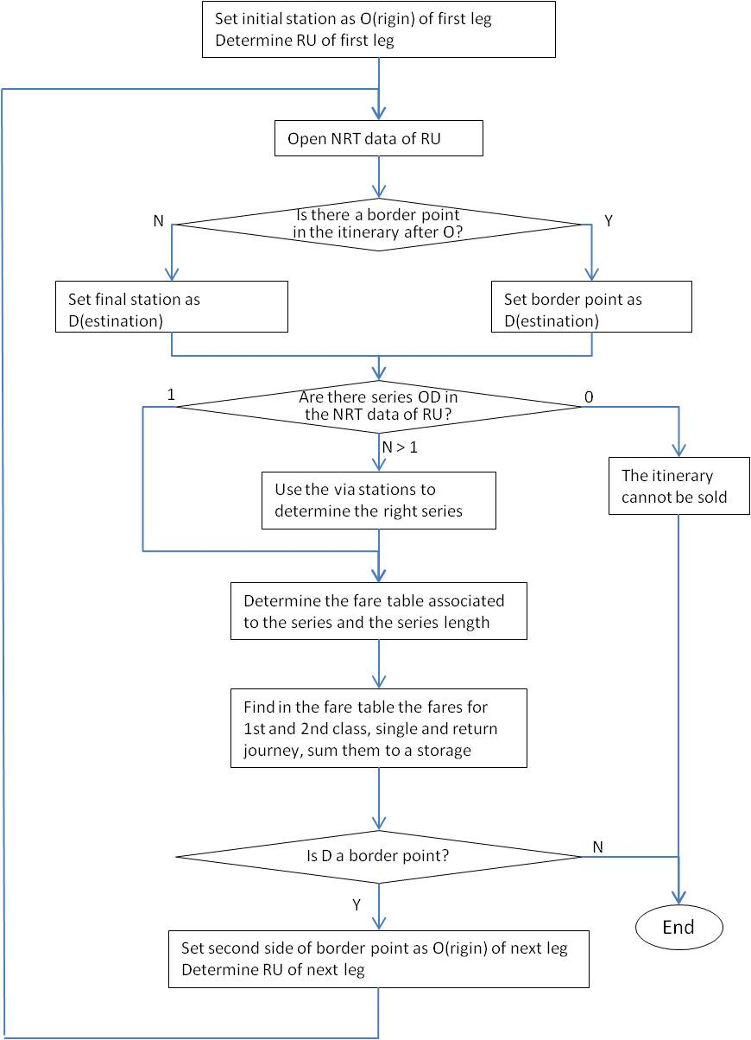

## B.2 IRT fares

An automated fare search for the possible IRT-fares can be performed when the train that the passenger intends to use is priced at Global price (value 2 in element “Product characteristic identification code”, tag 7139 of TD B.4 ).

In addition it is necessary to avail of the following elements:

* codes of the initial and final stations of the journey
* number and service brand of the train that the passenger intends to use
* date of the intended journey

All the above elements can be returned by a journey planner fed with timetable data according to B.4.

The fare calculation has to be done as described below:

:

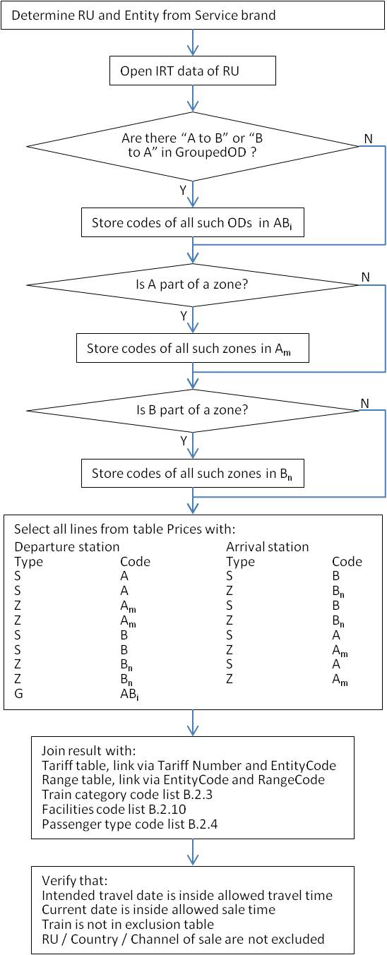

## B.3 Special offers

Please indicate here the same procedure description as for B.1 and B.2 for the calculation of the fare applicable for a passenger.

# Appendix C) - Data quality checks

## C.1 Checks on file sets for NRT tariffs according to TD B.1

|  |  |  |
| --- | --- | --- |
| N. | Check | Description |
| 1 | Format check: Date | It is carried out on all date fields of NRT B.1 files |
| 2 | Format check: Numeric | It is carried out on all numerical fields of NRT B.1 files |
| 3 | Format check: Digits | It is carried out on all decimal fields of NRT B.1 files (check on number of integer and decimal digits) |
| 4 | Coherence check: "Valid from" | It is carried out on all rows of NRT B.1 files; all rows must have the same value |
| 5 | Coherence check: "Version" | It is carried out on all rows of NRT B.1 files; all rows must have the same value |
| 6 | Coherence check: "Valid until" | It is carried out on all rows of NRT B.1 files; all rows must have the same value |
| 7 | Coherence check: "Code of the supplying RU" | It is carried out on all rows of NRT B.1 files; all rows must have the same value |
| 8 | Format check: Alpha-numeric fields | It is carried out on all alpha-numerical fields of NRT B.1 files |
| 9 | Format check: Carrier Code type | It is Carried out on Carrier-Code datatype fields; these must correspond to existing company codes in code list B.4.3039. |
| 10 | Domain check: flag key and flag field | Flag key and flag field must be valued with a value from attribute domain (respectively 1,2,3 and 0,3) |
| 11 | Format check: field type "file name" | "file name" must start with characters "TCV", if not numeric |
| 12 | Format check: field type "file name" | If "file name" begins with ”TCV', fourth character must assume one of the following values; 'G', 'S', ‘M’, 'T', 'O', 'C’, ‘P', ‘H’, ‘L’ |
| 13 | Format check: field type "file name" | Last four characters in fare file names must be numeric and equal to < Code of the supplying RU > |
| 15 | Format check: field type "file name" | Characters 35 to 42 in Header file must contain a valid file name |
| 16 | Format check: field type "file name" | Characters 5 to 8 in Fare table description file must be equal to first four characters of price file name |
| 17 | Domain check | Fields Value in NRT B.1 files must belong to attribute domain, including domains defined in code lists (example: field 'series type' in TCVSnnnn file must assume a value from attribute domain (1, 2, 3)) |
| 18 | Coherence check | If flag key assumes value 0, flag fields must assume a value from attribute domain (0,3) |
| 19 | Domain check | If flag key assumes value 1 or 2, flags field must assume value 0 |
| 20 | Supply check | Header file not communicated |
| 21 | Supply check | File declared in Fare table description not found between transferred files |
| 22 | Supply check | Mandatory file not found between transferred files. Mandatory files are: TCVnnnn, TCVCnnnn, TCVGnnnn, TCVSnnnn, TCVPnnnn and at least one fare table file |
| 23 | Supply check | At least one fare file must be declared in Header File |
| 24 | Primary key uniqueness check | Each row in each file must have a unique primary key |
| 25 | TCVCnnnn: Carrier Code | Carrier Code of RU managing the system must exist in Carrier file TCVCnnnn |
| 27 | TCVGnnnn: "Pictogram code" | "Pictogram code" fields must be valued in ascending sequence (example: Pictogram code 3 cannot be valued if Pictogram codes 1 and 2 are empty). |
| 28 | TCVGnnnn: "Pictogram code" | "Pictogram code" must correspond to existing pictogram code in code list B.1.2 |
| 29 | TCVGnnnn: "35 character station name" | Description uniqueness in TCVGnnnn file “(unless key flag for station code = 2) |
| 30 | TCVGnnnn: "17 character station name" | Description uniqueness in TCVGnnnn file “(unless key flag for station code = 2) |
| 31 | TCVGnnnn: "17 character reference to station route description" | Description uniqueness in TCVGnnnn file “(unless key flag for station code = 2) |
| 32 | TCVGnnnn: "17 character station name" | Field "17 character station name" must contain only upper or lower case letters without accents |
| 33 | TCVGnnnn: "17 character reference to station route description" | Field "17 character reference to station route description" must contain only upper or lower case letters without accents |
| 36 | TCVGnnnn: "Fare reference station" | TCVGnnnn is checked for the existence of a row with station code = "Fare reference station" |
| 37 | TCVGnnnn: "Fare reference station" | In case of existence of the row in TCVGnnnn related flag key must be equal to 2 |
| 38 | TCVGnnnn: coherence between "Fare reference station" and "17 character reference to station route description" | If "Fare reference code" is not empty, field "17 character reference to station route description" must filled only if station code = Fare reference code |
| 39 | TCVGnnnn: "Code for Accounting Station" | TCVGnnnn is checked for the existence of a row with station code = " Code for Accounting Station " |
| 40 | TCVGnnnn: " Code for Accounting Station " | If " Code for Accounting Station " is not empty it must be <> "station code" |
| 40b | TCVGnnnn: " Code for Accounting Station " | If exists " Code for Accounting Station" in TCVGnnnn, related flag key must be <> 2 |
| 41 | TCVGnnnn: existence " Station Code" ("external" referential integrity) | "Station code" must correspond to existing station code in the locations database |
| 42 | TCVGnnnn: "Station Code" | If "Station Code" exists in locations database, it must be active (end date empty) |
| 43 | TCVGnnnn: "35 character station name" | If "Station Code" exists in locations database, it must be equal to "35 character station name" of the station with same code in locations database |
| 44 | TCVGnnnn: "17 character station name" | If "Station Code" exists in locations database, it must be equal to "17character station name" of the station with same code in locations database |
| 45 | TCVGnnnn: "Border Point Code" | "Border Point Code" must correspond to existing Border Point Code in code list B.1.3 |
| 46 | TCVGnnnn: "Old station code" | Locations database is checked for the existence of a station with station code = "Old station code"; if exists this must not be active |
| 47 | "TCVGnnnn": "Code for fare reference station" | Locations database is checked for the existence of a station with station code = " Code for fare reference station "; if exists this must be active |
| 48 | TCVGnnnn: "Code for accounting station" | Locations database is checked for the existence of a station with station code = "Code for accounting station"; if exists this must not be active |
| 49 | TCVSnnnn: "code for the nth station in the route description" | Itinerary fields must be valued in ascending sequence  As an example if group of fields 48 (“code for the third station”), 49 (“Position of the third station”) and 50 (“Abridging code for the third station”) is filled in, previous groups 1 (fields 42, 43 and 44) and 2 (fields 45, 46 and 47) must be mandatorily filled in. In previous example fields 44 and 47 can remain unfilled, but others fields must be mandatorily filled |
| 50 | TCVSnnnn: "code for the nth station in the route description" | Single routing group must be filled coherently.  If field "Position" is filled in, "Routing Station" must be filled in and viceversa. "Abridging code" filled in requires that also the other two fields of the group are not empty |
| 51 | TCVSnnnn:"Position of the nth station" | The five Position flags must be valued coherently  First "Position" must be <"3"  "Position" "1" must be followed by "1" or "2"  "Position" "2" must be followed by "2" or "3"  "Position" "3" must be followed by "1" or "3"  Last "Position" must be <> "2" |
| 52 | TCVSnnnn:"Route" | Itinerary description" field must be coherent with description "calculated" starting from the five routing groups |
| 53 | TCVSnnnn: "Route" | Itinerary description field must not contain additional blanks; the only blanks admitted are those present in routing station names |
| 54 | TCVSnnnn: Route Number | Route Number field value must be unique for equal values of "Departure Station" and "Arrival Station" |
| 55 | TCVSnnnn: "Departure Station Code" | TCVGnnnn is checked for the existence of a station with "station code" = "Departure Station Code" |
| 56 | TCVSnnnn: "Departure Station Code" | If "Departure Station Code" exists in TCVGnnnn this must be active (flag key <> 2). |
| 57 | TCVSnnnn: "17-character name of Departure Station" | If "Departure Station Code" exists in TCVGnnnn, field "17-character name of Departure Station" must be equal to "17-character station name" if the "Departure station" is not a "Fare reference station" or with field "17-character reference to station route description" if the "Departure station" is a "Fare reference station" “(unless key flag for series = 2) |
| 58 | TCVSnnnn: "Arrival Station Code" | TCVGnnnn is checked for the existence of a station with "Station Code" = "Arrival Station Code" |
| 59 | TCVSnnnn: "Arrival Station Code" | If "Arrival Station Code" exists in TCVGnnnn this must be active (flag key <> 2). |
| 60 | TCVSnnnn: "17-character name of Arrival Station" | If "Arrival Station Code" exists in TCVGnnnn, field "17-character name of Arrival Station" must be equal to "17-character station name" if the "Arrival station" is not a "Fare reference station" or with field "17-character reference to station route description" if the "Arrival station" is a "Fare reference station" “(unless key flag for series = 2) |
| 58 | TCVSnnnn: "Type of series" | Departure and Arrival stations must be coherent with field "Type of series". If:  "Type of series" = 1 both stations must be border point stations  "Type of series" = 2 the "Departure station" must be a border point station and the “Arrival station” not  "Type of series" = 3 Stations must not be border points  Border point check is carried out on field "Border Point Code" in TCVGnnnn file |
| 59 | TCVSnnnn: "Type of series" and "Departure/Arrival station" | Departure and Arrival stations must be filled in alphabetical order if "Type of series" = "1" or "3"; If "Type of series" = "2" "Departure station" must be the border point station |
| 62 | TCVSnnnn: "Product Code" | TCVTnnnn is checked for the existence of a product with key equal to "Product Code" |
| 63 | TCVSnnnn: "Product Code" | If "Product Code" exists in TCVTnnnn, it must be active (flag <> "2"). |
| 66 | TCVSnnnn: "Fare Code" | TCVPnnnn is checked for the existence of a fare table with key equal to "Standard Fare table number" |
| 67 | TCVSnnnn: "Fare Code" | If "Standard Fare table number" exists in TCVPnnnn it must be active (flag <> "2"). |
| 68 | TCVSnnnn: "Standard Fare Calculation" | If "Standard Fare table number" exists in TCVPnnnn field "Standard Fare Calculation" must be equal to field "Table type" in TCVPnnnn file |
| 69 | TCVSnnnn: "Info on Routes" | TCVMnnnn is checked for the existence of a Memo with key equal to "Info Code" |
| 70 | TCVSnnnn: "Info on routes" | If "Info code" exists in TCVMnnnn it must be active (flag <> "2"). |
| 71 | TCVSnnnn: "Code for the nth station in the route description" | TCVGnnnn is checked for the existence of a station with "station code" = "Code for the nth station in the route description" |
| 71b | TCVSnnnn: "Code for the nth station in the route description" | If "Code for the nth station in the route description" exists in TCVGnnnn this must be active (flag key <> 2). |
| 72 | TCVSnnnn: "Code for the nth station in the route description" | If "Code for the nth station in the route description" exists in TCVGnnnn this must NOT be a border point station |
| 72b | TCVSnnnn: "Departure/ Arrival/ Routing Station Code" | "Station code" must correspond to existing station code in the locations database |
| 73 | TCVSnnnn: "Departure/ Arrival/Routing Station Code" | If "Station Code" exists in locations database, it must be active (end date empty) |
| 74 | TCVSnnnn: "Departure/ Arrival Station Code" | If "Station Code" exists in locations database, “17-character name for departure/arrival station” must be equal to "17character station name" of the station with same code in locations database |
| 75 | TCVSnnnn: "Departure Station Code" | If "Station Code" exists in locations database, it must be a border point if "Type of series" = 1 o 2 |
| 75b | TCVSnnnn: "Arrival Station Code" | If "Station Code" exists in locations database, it must be a border point if "Type of series" = 1 |
| 76 | TCVSnnnn: "Carrier Code" | TCVCnnnn is checked for the existence of a Carrier with key equal to "Carrier Code" |
| 77 | TCVMnnnn: "Line n in country's language" | Line n in country's language" must be filled in ascending sequence |
| 78 | TCVMnnnn: "Line n in French" | "Line n in French language" must be filled in ascending sequence |
| 79 | TCVMnnnn: "Line n in English" | "Line n in English language" must be filled in ascending sequence |
| 80 | TCVMnnnn: "Line n in German" | "Line n in German language" must be filled in ascending sequence |
| 82 | TCVTnnnn: "Fare Code" | TCVPnnnn is checked for the existence of a fare with key equal to "Fare table number" |
| 83 | TCVTnnnn: "Fare table number" | If "Fare table number" exists in TCVPnnnn, this must be active (flag <> "2"). |
| 84 | TCVOnnnn: "Fare Code" | TCVPnnnn is checked for the existence of a fare with key = "Fare table number" |
| 85 | TCVOnnnn: "Fare table number" | If "Fare table number" exists in TCVPnnnn, it must be active (flag <> "2"). |
| 86 | TCVPnnnn: coherence "Fare table number" | "Fare table number" must be equal to first four digits of the name of an existing fare table |
| 87 | TCVPnnnn: "Number of adults/ Number of children" | Must not be filled in for "Fare type " = 3 |
| 88 | TCVPnnnn: "File name" | Coherence with naming conventions |
| 89 | TCVPnnnn: "Discount on the standard TCV fare" | Filled in only if "Fare type" = "01" |
|  | TCVPnnnn: “Code indicating whether return fare is twice the single fare” | If set to “1” then the return fare for the corresponding fare table must be the double fare of the single fare. |
| 90 | Distance-based fare: " nth class single/return fare" | Four amount fields must not be simultaneously equal to zero |
| 91 | Distance-based fare: flag field with flag key in TCVpnnnn | If flag key in TCVPnnnn = 1 all flag fields must be = "0". If flag key in TCVPnnnn = 2 must not exist the related Distance-based file |
| 92 | Route based fare: "nth class single/return fare" | Four amount fields must not be simultaneously equal to zero |
| 93 | Route based fare: flag field with flag key in TCVpnnnn | If flag key in TCVPnnnn = 1 all flag fields must be = "0". If flag key in TCVPnnnn = 2 must not exist the related Route based file |
| 94 | Route based fare: "Series" | TCVSnnnn is checked for the existence of a row with key equal to "Series" (field 3 in Route based series) |
| 95 | Route based fare: fields repeated from TCVSnnnn | Fields in Route based Fare file repeated from TCVSnnnn (from 4 to 11) must assume equal values of those in TCVSnnn file |
| 96 | Set fare: amounts coherence (row level consistency) | Four amount fields must not be simultaneously equal to zero |
| 97 | Set fare: coherence flag field and flag key in TCVpnnnn (files set level consistency) | If flag key in TCVPnnnn = 1 all flag fields must be = "0". If flag key in TCVPnnnn = 2 must not exist the related Set fare file |
| 98 | Coherence with previous version | Rows with flag key = 2 in a new delivery must exist in the previous '01' version with flag key = 0 or 1 |
| 99 | Coherence with previous version | Rows with flag key = 0 in a new delivery must exist in the previous '01' version with flag key = 0 or 1 |
| 100 | Coherence with previous version | Rows with flag key = 1 in a new delivery must not exist in the previous two '01' versions |
| 101 | Coherence with previous version | Fields with flag field = 0 in the new delivery must exist in the previous version with the same value (rows with flag key = 0) |
| 102 | Coherence with previous version | Fields with flag field = 3 in the new delivery must have in the previous version a different value (rows with flag key = 0) |
| 103 | Coherence with Header File | Counters in Header file are checked against calculated counters |

## C.2 Checks on file sets for IRT tariffs according to TD B.2

|  |  |  |  |
| --- | --- | --- | --- |
| **Annex 1 “TARIFFS” file** | | | |
| **id** | **name** | **check-function** | **description** |
| 1 | Railway Code | Numeric format check. | It is carried out on all Railway Code fields of IRT B2 files. Only the Railway Code defined by the habilitation. |
| 2 | Code Entity | Alpha format check without accent. | It is carried out on all Code Entity fields of IRT B2 files. Code Entity must correspond to existing entity codes in code list B.2.1  Only the Entity Code(s) defined by the habilitation. |
| 3 | Entity name | Alpha format check |  |
| 4 | Tariff range | Numeric format check [00 not accepted] | It is carried out on all Tariff Range fields of IRT B2 files. Range number 01 to 10 are defined in the Code List B.2.6. |
| 5 | Tariff number | Numeric format check [ 000 not accepted] | It is carried out on all Tariff Number fields of IRT B2 files. |
| 6 | Code Tariff | Numeric format check | It is carried out on all Code Tariff fields of IRT B2 files. |
| 7 | Tariff name in local language | Alpha format check | Name given by the RU/Entity. Check is carried out on all “NAME” fields of IRT B2 files. |
| 12 | Sales date from | Date format check as YYYYMMDD | This date format check is carried out on all DATE fields of IRT B2 files. |
| 13 | Sales time from | Numeric format check : hh |  |
| 16 | Train category | Alpha format check with no-accents | Category of train defined in code list B.2.3. The check is carried out on all Train Category fields of B2 files. |
| 17 | Night Train | Check on Y or N value |  |
| 18 | Passenger Type | Numeric format check | Type of Passenger defined in code list B.2.4 . |
| 19 | Age passenger: from | Numeric format check |  |
| 20 | Age passenger: to | Numeric format check |  |
| 21 | Card/Memo | Check on Y or N value |  |
| 22 | Minimal number of travelers | Numeric format check |  |
| 23 | Maximal number of travelers | Numeric format check |  |
| 24 | Travel day | Check on Y or N value, on 7 digits (NNNYYYY) |  |
| 25 | Departure time from | Numeric format check, for every day of the week. | For each day of the week, starting Monday, if applicable, hour has to be set on 2 digits. |
| 26 | Departure time to | Numeric format check, for every day of the week. | For each day of the week, starting Monday, if applicable, hour has to be set on 2 digits. |
| 27 | Periods or train exclusion | Check on Y or N value |  |
| 28 | Maximum number of days before departure. | Numeric format check. |  |
| 29 | Minimum number of days before departure. | Numeric format check. Must be less than the maximum number of days before departure | . |
| 31 | And / or | Check on 0 or 1or 2 value |  |
| 32 | Minimum number of nights away condition | Numeric format check. It has to be less than the maximum number defined in field 33. |  |
| 33 | Maximum number of nights away condition | Numeric format check |  |
| 34 | Sales conditions | Check on Y or N value |  |
| 35 | Exchangeable | Check on Y or N value |  |
| 36 | Number of exchanges allowed | Numeric format check |  |
| 37 | Refundable | Check on Y or N value |  |
| 38 | Minimum price | Check on Y or N value |  |

|  |  |  |  |
| --- | --- | --- | --- |
| **Annex 2 “RANGE” file** | | | |
| **id** | **name** | **check-function** | **Description** |
| 3 | Code range | numeric format check [00 not accepted] | When over 10 in field 4 of annex 1, this annex 2 has to be filled up. |
| 4 | Range name in local language | Alpha format check. | Check is carried out on all Name fields of IRT B2 files |

|  |  |  |  |
| --- | --- | --- | --- |
| **Annex 3 “CARDS/MEMO” file (**Annex 3 has to be filled up if Y in field 21 of annex 1) | | | |
| **id** | **name** | **check-function** | **description** |
| 5 | Group | Check on value 0,1 or 2 |  |
| 6 | Card /memo | Numeric format check [00 not accepted] | Standard4/ Card codes defined in Code List B.2.7. |
| 7 | Country | Alpha format check with no-accents | Code on 3 alpha from ISO 3166.1. Check is carried out on all Country fields of IRT B2 files. |

|  |  |  |  |
| --- | --- | --- | --- |
| **Annex 4 “EXCLUSION” file** | | | |
| **id** | **name** | **check-function** | **Description** |
| 6 | Train number | Alpha format check | Number attributed by the RU |
| 7 | Railway code | Numeric format check | To set to 0000 as not used any more |
| 8 | Tariff validity days | Check on b, N or Y value on 7 digits |  |

|  |  |  |  |
| --- | --- | --- | --- |
| **Annex 5 “SALES CONDITIONS” file** | | | |
| **id** | **name** | **check-function** | **Description** |
| 5 | Railway/Country | Check on C or N value |  |
| 6 | Railway / Country code | Alpha format check with no-accents | Railway code defined in TD B8 on 4 numeric  Country code on 3 alpha from ISO 3166.1 |
| 7 | Authorisation or interdiction for Railway/Country | Check on Y or N value |  |
| 8 | Code distribution Channel | Numeric format check | Standard codes defined in Code List B.2.8. |
| 9 | Authorisation or interdiction for distribution channel | Check on Y or N value |  |

|  |  |  |  |
| --- | --- | --- | --- |
| **Annex 6 “AFTER SALES CONDITIONS” file** | | | |
| **id** | **name** | **check-function** | **Description** |
| 5 | Code type of after sales | Check on R or E value |  |
| 6 | Valid from number of days before/after departure | Numeric format check (including – or + sign) |  |
| 7 | Valid from number of hours before/after departure | Numeric format check (including – or + sign) |  |
| 8 | Valid to number days before/after departure | Numeric format check (including – or + sign) |  |
| 9 | Valid to number of hours before/after departure | Numeric format check (including – or + sign) |  |
| 10 | Amount | Numeric format check (3,2) | All Amount fields in IRT B2 files, are expressed in euro with 2 decimals and no decimal point. |
| 11 | Percentage | Numeric format check (3,2) | Percentage is expressed with 2 decimals and no decimal point: 15% is 01500 |

|  |  |  |  |
| --- | --- | --- | --- |
| **Annex 7 “PRICE” file** | | | |
| **id** | **name** | **check-function** | **Description** |
| 11 | Type of Origin station | Check on S, Z or G value |  |
| 12 | Code of origin station | Numeric format check | Check on 9 numeric is carried out on all Station fields of IRT B2 files. |
| 13 | Type of Destination station | Check on S or Z value |  |
| 14 | Code destination station | Numeric format check | Check on 9 numeric is carried out on all Station fields of IRT B2 files |
| 15 | Single/Return | Check on S or R value |  |
| 16 | Direction | Check on O, D or B value |  |
| 17 | Journey Type | Check on I or D value |  |
| 18 | Via Code | Numeric format check | As station code, check on 9 numeric |
| 19 | Border point Code | Numeric format check | Border point code defined in Code List B.2.9 |
| 20 | Facility Code | Numeric format check | Codes defined in Code List B.2.10 |
| 21 | Price | Numeric format check on 7 characters (5,2) | Amount expressed in euro with 2 decimals and no decimal point. |

|  |  |  |  |
| --- | --- | --- | --- |
| **Annex 8 “ZONE” file** | | | |
| **id** | **name** | **check-function** | **Description** |
| 3 | Code origin/ destination Zone | Numeric format check on 5 digits | Unique ID per zone defined by RU/Entity. |
| 4 | Name Zone | Alpha format check | Defined by the RU/Entity |
| 6 | Name of Station | Alpha format check with no-accents |  |

|  |  |  |  |
| --- | --- | --- | --- |
| **Annex 8b “GROUPED OD” file** | | | |
| **id** | **name** | **check-function** | **Description** |
| 3 | Code Origin/ Destination Group | Numeric format check, on 5 digits | Unique ID per group of OD defined by RU/Entity. |
| 4 | *Name OD Group* | Alpha format check | Defined by the RU/ Entity |

|  |  |  |  |
| --- | --- | --- | --- |
| **Annex 9 “NAME CARDS/MEMO” file** | | | |
| **id** | **name** | **check-function** | **Description** |
| 3 | Indicator Card or Memo | Check on C or M value |  |
| 4 | Code Card/Memo | Numeric format check [00 not accepted] | Unique ID per Card or Memo given by the RU/Entity |
| 5 | Description local language | Alpha format check | Text given by the RU/Entity to name the specific card or to define the memo |

|  |  |  |  |
| --- | --- | --- | --- |
| **Annex 10 “DISTRIBUTION” file** | | |  |
| **id** | **name** | **check-function** | **Description** |
| 3 | Distribution Channel Code | Numeric format check | Code over 10 decided by the RU/ Entity |
| 4 | Channel name local language | Alpha format check | Name given by the RU/Entity |

|  |  |  |  |
| --- | --- | --- | --- |
| **Annex 11 “TARIFF COMBINATIONS/DYNAMIC PRICES FROM” file** | | | |
| **id** | **name** | **check-function** | **Description** |
| 3 | Tariff Combination or Dynamic Price from/to | Alpha format check with no-accents |  |
| 4 | Tariff 1 | Numeric format check | Code tariff on 2 digits |
| 5 | Tariff 2 | Numeric format check | Code tariff on 2 digits |

## C.3 Checks on file sets for Special Offers according to TD B.3

|  |  |  |
| --- | --- | --- |
| N. | Check | Description |
| 1 | Format check: Numeric | All fields defined numeric must only contain digits |
| 2 | Format check: Alphanumeric | All fields defined alphanumeric must only contain letters and digits |
| 3 | Format check: Boolean | All fields defined Boolean (“Y/N”) must only contain “true” or “false” |
| 4 | Format check : specific | Field 4 of file OFOF must contain “F” or “S” |
| 5 | Format check : specific | Field 9 of file OFSE and field 10 of Route-based fare tables must contain “<” |
| 6 | Format check : specific | Field 11 of file OFSE and field 12 of Route-based fare tables must contain “>” |
| 7 | Format check : specific | Fields 5, 7, 9 and 11 of file OFGB must contain “+” or “-“ |
| 8 | Code lists check | Field 40 of file OFCO, field 8 of file OFPA, field 9 of file OFAR and field 6 of file OFFP must contain values present in code list B.3.11 |
| 9 | Code lists check | Field 16 of file OFGB must contain values present in code list B.3.16 |
|  |  |  |

# Appendix D) - XML messages

## D.1 Sample from “Company.xml”

<?xml version="1.0" encoding="UTF-8" standalone="yes"?>

<Companies xmlns=" http:// era.europa.eu/ …” (to be defined)

xmlns:xsi="http://www.w3.org/2001/XMLSchema-instance" xsi:noNamespaceSchemaLocation="replication.xsd">

<Company>

<Company_Name>Armenian Railway CJSC</Company_Name>

<Company_UIC_Code>0058</Company_UIC_Code>

<Country_ISO_Code>AM</Country_ISO_Code>

<Start_Validity>1999-06-01T00:00:00.000</Start_Validity>

<Company_Short_Name>ARM</Company_Short_Name>

<Contact_Details>

<Contact_Person>Mr V. Badalyan</Contact_Person>

<Address>50, rue Tigran Metge</Address>

<City>Yerevan</City>

<Postal_Code>370005</Postal_Code>

</Contact_Details>

<Freight_Flag>true</Freight_Flag>

<Infrastructure_Flag>true</Infrastructure_Flag>

<Active_Flag>true</Active_Flag>

</Company>

## D.2 Sample from “country.xml”

<?xml version="1.0" encoding="UTF-8" standalone="yes"?>

<Countries xmlns=" http:// era.europa.eu/ …” (to be defined)

xmlns:xsi="http://www.w3.org/2001/XMLSchema-instance" xsi:noNamespaceSchemaLocation="replication.xsd">

<Country>

<Country_ISO_Code>AL</Country_ISO_Code>

<Country_UIC_Code>41</Country_UIC_Code>

<Country_Name_EN>Albania</Country_Name_EN>

<Country_Name_FR>Albanie</Country_Name_FR>

<Country_Name_DE>Albanien</Country_Name_DE>

<Sub_Loc_Code_Flag>true</Sub_Loc_Code_Flag>

</Country>

## D.3 Sample from “primaryLocation.xml”

<?xml version="1.0" encoding="UTF-8" standalone="yes"?>

<PrimaryLocations xmlns=" http:// era.europa.eu/ …” (to be defined)

xmlns:xsi="http://www.w3.org/2001/XMLSchema-instance" xsi:noNamespaceSchemaLocation="replication.xsd">

<Primary_Location>

<Country_ISO_Code>FI</Country_ISO_Code>

<Location_Code>00001</Location_Code>

<Start_Validity>1989-01-01T00:00:00.000</Start_Validity>

<End_Validity>2016-02-17T00:00:00.000</End_Validity>

<ResponsibleIM>0010</ResponsibleIM>

<Location_Name>HELSINKI</Location_Name>

<Location_Name_ASCII>HELSINKI</Location_Name_ASCII>

<NUTS_Code>FI123</NUTS_Code>

<Container_Handling_Flag>true</Container_Handling_Flag>

<Handover_Point_Flag>true</Handover_Point_Flag>

<Longitude>-180.000000</Longitude>

<Latitude>90.000000</Latitude>

<Free_Text>test description</Free_Text>

<Active_Flag>true</Active_Flag>

</Primary_Location>

## D.4 Sample from “subsidiaryCodes.xml”

<?xml version="1.0" encoding="UTF-8" standalone="yes"?>

<SubsidiaryTypes xmlns=" http:// era.europa.eu/ …” (to be defined)

xmlns:xsi="http://www.w3.org/2001/XMLSchema-instance" xsi:noNamespaceSchemaLocation="replication.xsd">

<SubsidiaryType>

<Subsidiary_Type_Code>01</Subsidiary_Type_Code>

<Subsidiary_Type_Name>Track</Subsidiary_Type_Name>

<IM_Flag>true</IM_Flag>

<Free_Text>The track is a uniquely defined part of location</Free_Text>

</SubsidiaryType>

## D.5 Sample from “subsidiaryLocation.xml”

<?xml version="1.0" encoding="UTF-8" standalone="yes"?>

<SubsidiaryLocations xmlns=" http:// era.europa.eu/ …” (to be defined)

xmlns:xsi="http://www.w3.org/2001/XMLSchema-instance" xsi:noNamespaceSchemaLocation="replication.xsd">

<Subsidiary_Location>

<Country_ISO_Code>BE</Country_ISO_Code>

<Responsible_IM_Code>0088</Responsible_IM_Code>

<Subsidiary_Location_Code>11019</Subsidiary_Location_Code>

<Location_Code>11023</Location_Code>

<Subsidiary_Type_Code>04</Subsidiary_Type_Code>

<Subsidiary_Location_Name>SCHAERBEEK, AVANT-PORT/VOORHAVEN</Subsidiary_Location_Name>

<Start_Validity>1989-12-07T00:00:00.000</Start_Validity>

<AllocationCompany>3011</AllocationCompany>

<Active_Flag>true</Active_Flag>

</Subsidiary_Location>